Acoustic Rapid COTS Insertion (ARCI)

Software Requirements Specification (SRS)

Program Control Directives (PCD) Tracker



**“Keep It Simple”**

Prepared For:

Joey Eubank | Program Management Senior Manager | 703-367-3214

Prepared By:

Lockheed Martin Corporation

Rotary and Missions Systems (RMS)

9500 Godwin Drive

Manassas, VA 20110

Eugene J. Belford

CONTRACT NUMBER:

Document Name:

Point of Contact

Cyrus Sabzevari | Software Engineering Manager | 703-367-6366

[cyrus.sabzevari@lmco.com](mailto:cyrus.sabzevari@lmco.com)

Change History

|  |  |  |  |
| --- | --- | --- | --- |
| **Date** | **Version** | **Description** | **Author** |

|  |  |  |  |
| --- | --- | --- | --- |
| 5/23/2017 | 0.1 | Working Copy | Belford |
|  | 1.0 | Initial Draft | Belford |
|  |  |  |  |
|  |  |  |  |
|  |  |  |  |
|  |  |  |  |
|  |  |  |  |
|  |  |  |  |
|  |  |  |  |

Table of Contents

1. Purpose 1

1.1 Overview 1

1.2 Objectives 1

1.3 Requirements 1

1.4 Overview 2

2. Tracker Functions 3

2.1 PCD Status View 3

2.1.1 Human Machine Interfaces 4

2.1.2 Requirements 4

2.1.3 Business Rules 4

2.1.4 Functions 5

2.1.5 Data Objects 5

2.1.6 Views 5

2.1.7 Complexity 5

2.2 PCD Status Search / Report Parameters 6

2.2.1 Human Machine Interfaces 7

2.2.2 Requirements 7

2.2.3 Business Rules 7

2.2.4 Functions 7

2.2.5 Data Objects 8

2.2.6 Enumerations 8

2.2.7 Complexity 8

2.3 PCD Tracker Entry 9

2.3.1 Human Machine Interface 10

2.3.1.1 PCD Tracker Entry (Blank) 10

2.3.1.2 PCD Tracker Entry (Populated) 13

2.3.1.3 Requirements 13

2.3.1.4 Business Rules 13

2.3.2 Functions 13

2.3.3 Data Objects 14

2.3.4 Enumerations 14

2.3.5 Complexity 14

2.4 PCD Tracker Maintenance 15

2.4.1 Human Machine Interfaces 16

2.4.2 Requirements 17

2.4.3 Business Rules 17

2.4.4 Functions 17

2.4.5 Data Objects 17

2.4.6 Enumerations 17

2.4.7 Complexity 17

2.5 PCD Hardware List Entry 17

2.5.1 Human Machine Interfaces 19

2.5.2 Requirements 20

2.5.3 Business Rules 20

2.5.4 Functions 20

2.5.5 Data Objects 20

2.5.6 Enumerations 20

2.5.7 Complexity 20

2.6 PCD Draft 21

2.6.1 Human Machine Interfaces 21

2.6.1.1 PCD Draft (Collapsed) 21

2.6.1.2 PCD Draft (Expanded I) 23

2.6.1.3 PCD Draft (Expanded II) 25

2.6.2 Functions 26

2.6.3 Data Objects 26

2.6.4 Enumerations 26

2.6.5 Complexity 26

2.7 PCD Entry 27

2.7.1 Human Machine Interfaces 27

2.7.2 Requirements 28

2.7.3 Business Rules 28

2.7.4 Functions 28

2.7.5 Data Objects 28

2.7.6 Enumerations 28

2.7.7 Complexity 28

2.8 PCD Generic View 29

2.8.1 Human Machine Interfaces 29

2.8.1.1 (I) 29

2.8.1.2 (II) 30

2.8.1.3 Buttons 30

2.8.2 Views 31

2.8.3 Functions 31

2.8.4 Data Objects 31

2.8.5 Enumerations 31

2.8.6 Complexity 31

2.9 [CSC Name] CSC 32

2.9.1 [Function Name] 32

2.9.1.1 Test Method 32

2.9.1.2 Algorithms (if applicable) 32

2.9.1.3 SW Reuse (if applicable) 32

2.9.1.4 Requirements Traceability 32

3. PCD Working Modes 33

4. Common Function 34

4.1 Enumeration Helpers 34

4.1.1 Human Machine Interfaces 34

4.1.1.1 Drop Down List Box 34

4.1.1.2 Modal 35

4.1.2 Views 35

4.1.3 Functions 35

4.1.4 Data Objects 35

4.1.5 Enumerations 35

4.1.6 Complexity 36

4.2 Enumeration Types 36

4.2.1 Human Machine Interfaces 36

4.2.2 Requirements 36

4.2.3 Business Rules 37

4.2.4 Views 37

4.2.5 Functions 37

4.2.6 Data Objects 37

4.2.7 Enumerations 37

4.2.8 Complexity 37

4.3 Enumeration Values 37

4.3.1 Human Machine Interfaces 38

4.3.2 Requirements 38

4.3.3 Business Rules 38

4.3.4 Views 38

4.3.5 Functions 38

4.3.6 Data Objects 38

4.3.7 Enumerations 38

4.3.8 Complexity 39

4.4 Enumeration Value Associations 39

4.4.1 Human Machine Interfaces 39

4.4.2 Requirements 39

4.4.3 Business Rules 39

4.4.4 Views 39

4.4.5 Functions 39

4.4.6 Data Objects 39

4.4.7 Enumerations 39

4.4.8 Complexity 39

4.5 Printable Version 40

4.5.1 Human Machine Interfaces 40

4.5.2 Requirements 40

4.5.3 Business Rules 40

4.5.4 Views 40

4.5.5 Functions 40

4.5.6 Data Objects 40

4.5.7 Enumerations 40

4.5.8 Complexity 41

4.6 Classification 41

4.6.1 Human Machine Interfaces 41

4.6.2 Requirements 41

4.6.3 Business Rules 42

4.6.4 Views 42

4.6.5 Functions 42

4.6.6 Data Objects 42

4.6.7 Enumerations 42

4.6.8 Complexity 42

4.7 Contracts / Purchase Order(s) 42

4.7.1 Human Machine Interfaces 43

4.7.2 Requirements 43

4.7.3 Business Rules 43

4.7.4 Views 43

4.7.5 Functions 43

4.7.6 Data Objects 43

4.7.7 Enumerations 43

4.7.8 Complexity 43

4.8 Assign Approver(s) 44

4.8.1 Human Machine Interfaces 44

4.8.2 Requirements 44

4.8.3 Business Rules 44

4.8.4 Views 44

4.8.5 Functions 44

4.8.6 Data Objects 44

4.8.7 Enumerations 44

4.8.8 Complexity 45

4.9 Action Responsible Person(s) / Additional Resources 45

4.9.1 Human Machine Interfaces 45

4.9.2 Requirements 45

4.9.3 Business Rules 46

4.9.4 Views 46

4.9.5 Functions 46

4.9.6 Data Objects 46

4.9.7 Enumerations 46

4.9.8 Complexity 46

4.10 Assign Programs 46

4.10.1 Human Machine Interfaces 47

4.10.2 Requirements 47

4.10.3 Business Rules 47

4.10.4 Views 47

4.10.5 Functions 47

4.10.6 Data Objects 47

4.10.7 Enumerations 47

4.10.8 Complexity 47

4.11 Attachments 48

4.11.1 Human Machine Interfaces 48

4.11.2 Requirements 49

4.11.3 Business Rules 49

4.11.4 Views 49

4.11.5 Functions 49

4.11.6 Data Objects 50

4.11.7 Enumerations 50

4.11.8 Complexity 50

4.12 PCD Notification 50

4.12.1 Human Machine Interfaces 50

4.12.2 Requirements 51

4.12.3 Business Rules 51

4.12.4 Views 51

4.12.5 Functions 51

4.12.6 Data Objects 51

4.12.7 Enumerations 51

4.12.8 Complexity 51

4.13 PCD Users Guide 52

4.13.1 Human Machine Interfaces 52

4.13.2 Requirements 52

4.13.3 Business Rules 52

4.13.4 Views 52

4.13.5 Functions 52

4.13.6 Data Objects 52

4.13.7 Enumerations 53

4.13.8 Complexity 53

5. Application Functions 54

5.1 Contracts/Program List 54

5.1.1 Human Machine Interfaces 54

5.1.2 Requirements 55

5.1.3 Business Rules 55

5.1.4 Views 55

5.1.5 Functions 55

5.1.6 Data Objects 55

5.1.7 Enumerations 55

5.1.8 Complexity 55

5.2 Administration 55

5.2.1 Human Machine Interfaces 55

5.2.2 Requirements 55

5.2.3 Business Rules 56

5.2.4 Views 56

5.2.5 Functions 56

5.2.6 Data Objects 56

5.2.7 Enumerations 56

5.2.8 Complexity 56

5.3 PCD Summary 56

5.3.1 Human Machine Interfaces 57

5.3.2 Requirements 57

5.3.3 Business Rules 57

5.3.4 Views 57

5.3.5 Functions 57

5.3.6 Data Objects 57

5.3.7 Enumerations 57

5.3.8 Complexity 57

5.4 PCD Report 58

5.4.1 Human Machine Interfaces 58

5.4.2 Requirements 58

5.4.3 Business Rules 58

5.4.4 Views 58

5.4.5 Functions 58

5.4.6 Data Objects 59

5.4.7 Enumerations 59

5.4.8 Complexity 59

5.5 PCD Statistics 59

5.5.1 Human Machine Interfaces 59

5.5.2 Requirements 60

5.5.3 Business Rules 60

5.5.4 Views 60

5.5.5 Functions 61

5.5.6 Data Objects 61

5.5.7 Enumerations 61

5.5.8 Complexity 61

5.6 Contract Entry 61

5.6.1 Human Machine Interfaces 61

5.6.2 Requirements 61

5.6.3 Business Rules 61

5.6.4 Views 61

5.6.5 Functions 61

5.6.6 Data Objects 61

5.6.7 Enumerations 62

5.6.8 Complexity 62

5.7 Program Entry 62

5.7.1 Human Machine Interfaces 62

5.7.2 Requirements 62

5.7.3 Business Rules 62

5.7.4 Views 62

5.7.5 Functions 62

5.7.6 Data Objects 62

5.7.7 Enumerations 62

5.7.8 Complexity 62

5.8 User Entry 63

5.8.1 Human Machine Interfaces 63

5.8.2 Requirements 63

5.8.3 Business Rules 63

5.8.4 Views 63

5.8.5 Functions 63

5.8.6 Data Objects 63

5.8.7 Enumerations 63

5.8.8 Complexity 63

6. Use Cases 64

6.1.1 [Use Case Name] 64

6.1.1.1 [Sequence | Activity] Diagram Name (optional) 64

6.1.1.2 Basic Flow 64

6.1.1.3 Alternate Flows 64

6.1.1.4 Exceptional Flows 64

7. Data Model 65

7.1 Table Trackers 65

7.2 Table Program Control Directives (PCD) 66

7.3 Table Hardware Lists 68

7.4 Table Hardware List Items 68

7.5 Table Remarks 69

7.6 Table Tasks 69

7.7 Table User Tasks 70

7.8 Table Contracts 70

7.9 Table Search Parameters 71

7.10 Table Attachments 71

7.11 Table Enumeration Types 72

7.12 Table Enumeration Values 72

7.13 Table Enumeration Value Associations 73

7.14 Table Boilerplate Suffix 73

7.15 Table blank 74

8. [CSCI Name] CSCI 75

8.1 [CSC Name] CSC 75

8.1.1 [Function Name] 75

8.1.1.1 Test Method 75

8.1.1.2 Algorithms (if applicable) 75

8.1.1.3 SW Reuse (if applicable) 75

8.1.1.4 Requirements Traceability 75

8.2 Data Model 75

8.3 Interfaces 75

8.3.1 Graphical Interfaces (if applicable) 75

8.3.2 Message Interfaces (if applicable) 75

8.3.2.1 Provided Interfaces 75

8.3.2.2 Required Interfaces 76

9. Appendixes 76

9.1 Acronyms 76

9.2 Enumeration Types 77

9.3 Enumeration Values 78

Tables

Table 2‑1: PCD Working Modes 33

Table 6‑2: Trackers 65

Table 6‑3: Program Control Directives (PCD) 66

Table 6‑4: Hardware Lists 68

Table 6‑5: Hardware List Items 68

Table 6‑6: Remarks 69

Table 6‑7: Tasks 69

Table 6‑8: User Tasks 70

Table 6‑9: Contracts 70

Table 6‑10: Search Parameters 71

Table 6‑11: Attachments 71

Table 6‑11: Enumeration Types 72

Table 6‑12: Enumeration Values 72

Table 6‑13: Enumeration Value Associations 73

Table 6‑14: Boilerplate 73

Table 6‑1: Blank 74

Figures

Figure 2‑1: PCD Status View 4

Figure 2‑2: PCD Status Search / Report Parameters 7

Figure 2‑3: PCD Tracker Entry (Blank) 10

Figure 2‑4: PCD Tracker Entry (Populated) 13

Figure 2‑5: PCD Tracker Maintenance 16

Figure 2‑6: PCD Hardware Entry List 19

Figure 2‑7: PCD Draft (Collapsed) 21

Figure 2‑8: PCD Draft (Expanded I) 23

Figure 2‑9: PCD Draft (Expanded II) 25

Figure 2‑10: PCD Entry 27

Figure 2‑11: PCD Generic View (I) 29

Figure 2‑12: PCD Generic View (II) 30

Figure 4‑1: PCD Statistics (Totals) 59

Figure 4‑2: PCD Statistics (Contract) 60

Figure 4‑3: PCD Statistics (Program) 60

Figure 6‑1: Data Model 65

Notes on comments heard

Host on SILC with other ARCI Tools

COTS

Workfront <https://www.workfront.com/>

# Purpose

This document establishes the Program Control Directives (PCD) Tracker requirements for the Acoustic Rapid Commercial off the Shelf (COTS) Insertion (ARCI).

The PCD tool is not integrated with other ARCI processes and there are no plans or funding at the Enterprise level to improve or update it. Actual placement of materials purchase orders after issuance of a PCD takes too long in many cases. Timelines and RIs are inconsistent from order to order.

## Overview

The Program Control Directive (PCD) application handles the generating, routing, approving and filing/archiving of Program Control Directives. PCD’s are used by the Program Office to direct and authorize personnel to perform actions outside normal circumstances. Common actions are to procure certain pieces of hardware, loan items to other facilities temporarily, and to stop work on a specific work package until requirements are clear.

## Objectives

* Implement an efficient standardized process to get authorized ARCI materials on order quickly
* Reduce process time between PCD and placement of purchase orders
* Replace PCD with an updated tool/toolset that is compatible with or can be integrated with downstream ARCI processes.
* Improve efficiency by reducing administrative/management labor to issue/update program direction

## Requirements

* The PCD tool is over 16 years old
  + Update to new standards and best practices
  + Update user interface
* Retain all current PCD functionality
  + PCD is used by multiple organizations
  + PCD is used by multiple programs
  + Avoid changes that will reduce current users’ ability to use the tool
* Add new functionality to satisfy ARCI needs that any program may opt to use or not without additional modifications
  + Maintains PCD as an Enterprise Business tool
  + May reduce cost of updates to ARCI Program

## Overview

* Authorize Work
* Authorize work in accordance with Contract SLINs or FEAs
  + - Initial ARCI Production Work Authorization Directives (WADs)
    - ARCI Engineering Services in accordance with Technical Instructions
* Satisfy ARCI Production PPMP requirements for initial WADs
* Purchase Materials to Support Production or Development
* PM direction to purchase materials
* Attach quotes or other documents to support purchases
* Provide labor and material work packages
* Describe what needs to be done, by whom and when
* Integrate PCD Tracking
  + - Initial identification of requirements
    - Ensure pre-requisites are satisfied (e.g. PLs, Part Numbers, BOMs)
    - Provide data and reports to support weekly review of progress
    - Manage process from initial identification of requirements to PR issue
* Other Program Communications
* Delegations of Authority
* Significant information of interest to program-wide distribution

# Tracker Functions

## PCD Status View

Upon entry into the PCD Tracker application the user will see the HMI, shown below, with the default PCD filter set to “Not Funded”. Changes the user makes to the data being displayed will be saved in the supporting data record. (Provide an Excel like look and feel.) Each data line will have a hyperlink to the corresponding PCD.

Predefined business filters will be available to view the PCD data. Switching between filters with cause the HMI to refresh automatically. To match the original PCD functionality the <pcd status> were added as filters. The user can select to display all the data columns or pre-defined sets of columns. The user can enter their own search parameters to conduct custom searches of the PCD data.

When the user clicks on the record’s hyperlink the HMI will change to the “PCD Tracker Data View” where the user will be able to review and update the task(s) associated with the PCD.

When the user clicks on the “Search Parameters” button the system will display the “PCD Search/Report Parameters” HMI where the user can set the search parameters and either execute the search or generate a PCD report.

When the users clicks on the “New PCD Task” button the user will be taken to the “PCD Tracker Entry” HMI where the user can create a new task.

When the users clicks on the “New PCD” button the user will be taken to the “PCD Entry” HMI where the user can create a new PCD. This function allows to create a PCD that does not require the completion of tasks such as a delegation of authority.

### Human Machine Interfaces

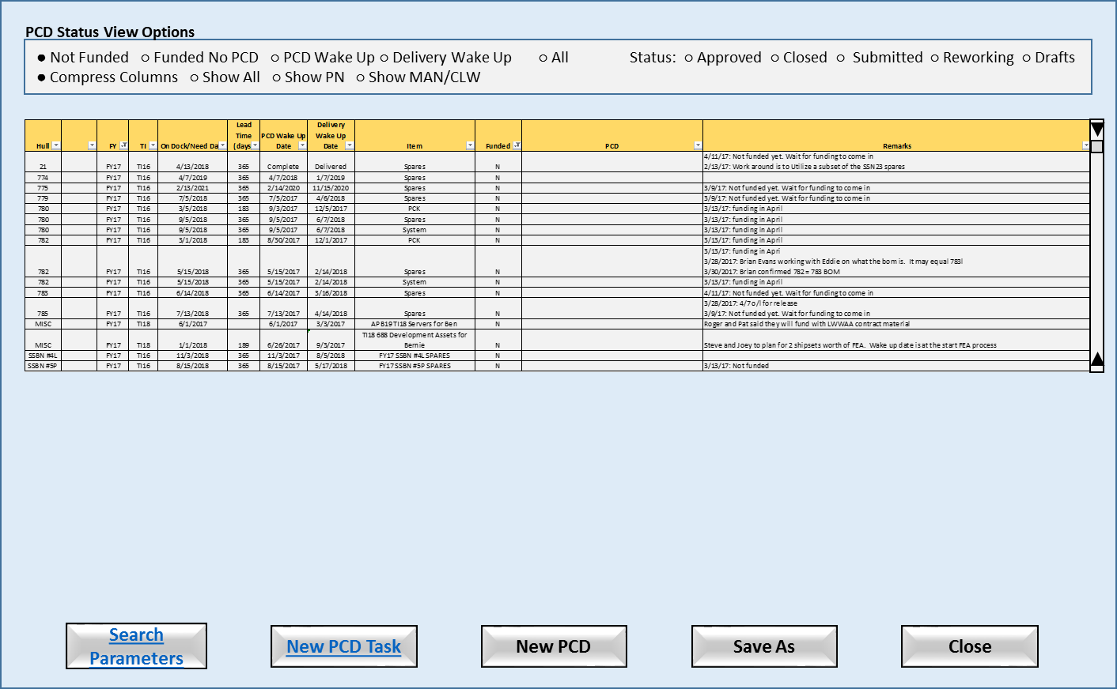

Figure 2‑1: PCD Status View

* Search Parameters: Allows to enter custom parameters to search PCD records.
* New PCD Task: Allows the user to start a new PCD tracker task into the system.
* New PCD: Allows the user to start a new PCD that does not tasks.
* Save As: Allows the user to save the contents of the data panel to a file.
* Close: Close the application.

### Requirements

1. The system will highlight data values for the users that violate the business rules.
2. The system will allow the user to view the source data record using the “Tracker Data View” HMI by selecting a record from the “Status View”.
3. The system will allow the user to add a new PCD task.
4. The system will allow the user to search for PCD tasks using user provide search parameters.
5. The system will automatically provide the required scroll bars if the data exceeds the size of the display panel.
6. The system will allow the user to sort the contents of the display panel.
7. The system will allow the user to save the contents of the display panel to a file.

### Business Rules

1. When the PCD Wakeup date is before or is the same as the current date, the PCD Wakeup date cell will be highlighted in yellow.
2. Any changes to a PCD with an “approved” status will trigger the creation of a revision PCD.

### Functions

1. Search Filter
2. Enumeration Value Helper

### Data Objects

1. Table 6‑2: Trackers
2. Table 6‑3: Program Control Directives (PCD)

### Views

1. Not Funded (FY: active, PCD: active, Funded: N) (Compress)
2. Funded No PCD (FY: active, PCD: active, Funded: Y) (Compress)
3. PCD Wake Up (Order by PCD Required Date descending) (Compress)
4. Delivery Wake Up (Order by Del Required Date descending) (Compress)
5. Search (user supplied search parameters) (Show All)
6. Approved (Status: approved) (Show All)
7. Closed (Status: closed) (Show All)
8. Submitted (Status: submitted) (Show All)
9. Reworking (Status: rework) (Show All)
10. Drafts (Status: draft) (Show All)

### Complexity

|  | Count |
| --- | --- |
| Inputs | 18 |
| Outputs | 3 |
| Inquires | 4 |
| Files/Tables | 8 |
| Ext. Files | 0 |
| Total: | 33 |

## PCD Status Search / Report Parameters

This HMI provides the user with the ability to define their own PCD search or report criteria. Once the user has completed entering the parameters the user will click on either the “Search” button to execute the search and populate the “PCD Status View”, or the “Report” button to execute the search and saves the results to a spreadsheet. If the search fails to find any matching records the system will display a message for the user that no matching records where found. If the search does find matches the system will return the user to the “Status View” HMI and refresh the view with the search results. Clicking the “Clear Search” will set the parameters back to their default values.

When the search button is pressed, the user is presented with a screen where the search criteria are entered. Entering data in any of the search fields indicates that the resulting PCD's must contain that criteria. Wildcards are allowed and are specified using a "*".

Once the search has completed, a list of all resulting PCD's is displayed. Hyperlinks are available to each PCD which allow the user to work with the corresponding PCD in the same manner which is available from the Contracts/Programs option. See Section 4.1 - Contracts/Programs

### Human Machine Interfaces

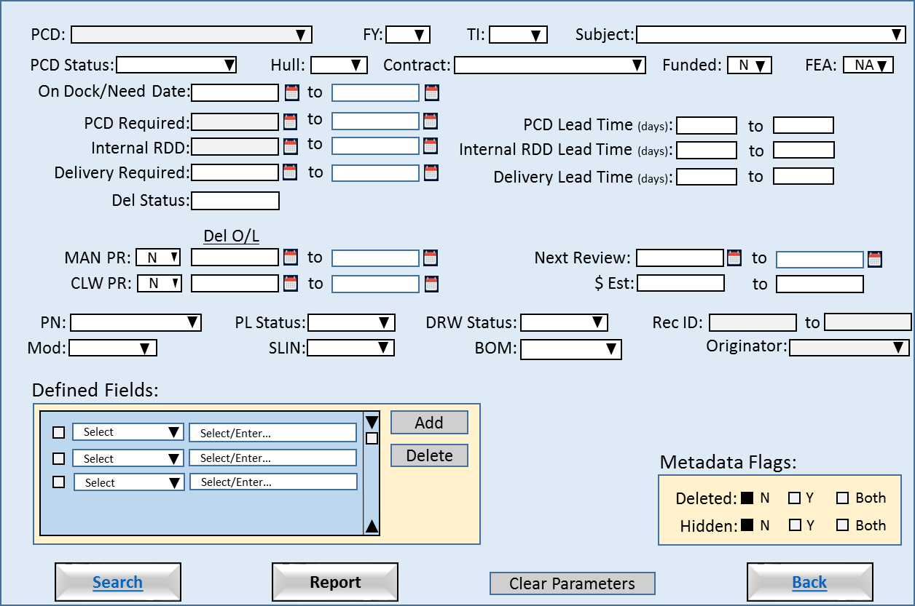

Figure 2‑2: PCD Status Search / Report Parameters

* Search: Executes a search for PCDs using the user provided parameters.
* Report: Generates a report for PCDs found using the user provided parameters.
* Clear Parameters: Sets the parameters back to their default values.
* Back: Returns to the “PCD Status View”.

### Requirements

1. The system will require at 1 search parameter be provided by the user.
2. The system will allow the user to perform wildcards searches.
3. The system will retain the last successfully search parameters.
4. The system will re-populate the parameters using the last successfully search parameters.
5. The system will allow the user rest the search parameters to their default values.

### Business Rules

1. Null search parameters will not be used in the search.
2. Empty strings are valid parameters. (Think about the wording.)
3. The “from” date is less than or equal to the “to” date.

### Functions

* Calendar
* Search Filter

### Data Objects

1. Table 6‑2: Trackers
2. Table 6‑3: Program Control Directives (PCD)
3. Table 6‑10: Search Parameters

### Enumerations

1. FY
2. TI
3. PCD Status
4. Hull
5. Contract
6. T/F (Funded, MAN PR, CLW PR)
7. FEA
8. Delivery Status
9. Part Number
10. Part List Status
11. Drawing Status
12. Mod
13. SLIN
14. BOM
15. Users (Originator)
16. Defined Fields

### Complexity

|  | Count |
| --- | --- |
| Inputs | 24 |
| Outputs | 1 |
| Inquires | 10 |
| Files/Tables | 2 |
| Ext. Files | 0 |
| Total: | 37 |

## PCD Tracker Entry

This HMI allows the user to enter and/or update common information needed for a related set of tasks. The user can add and/or delete remarks regarding the activity from this HMI. These remarks will be included in the draft PCD where the user can choose to exclude the remarks from the PCD submission. The “defined fields” allows the user to add program specific terms.

The “tasks” panel provides an area where the user can view sub-tasks related to the PCD. These are tasks that require completion before the PCD can be submitted. This allows management to be able to track the PCD development a finer level of detail. The “task maintenance” button provides the user access the “PCD Tracker Maintenance” HMI. When the user exits the “task maintenance” function the system will refresh the “tasks” panel.

The “hardware list” button provides the user with the functionality need to create a hardware list for PCD from the PCD application. Changes to the hardware list would cause the system version the PCD. Human Machine Interfaces.

Xxxxxx-ARCI-FY-TI-SEQ#

The “copy” button includes copying the tasks.

Sort/filter for tasks?

### Human Machine Interface

#### PCD Tracker Entry (Blank)

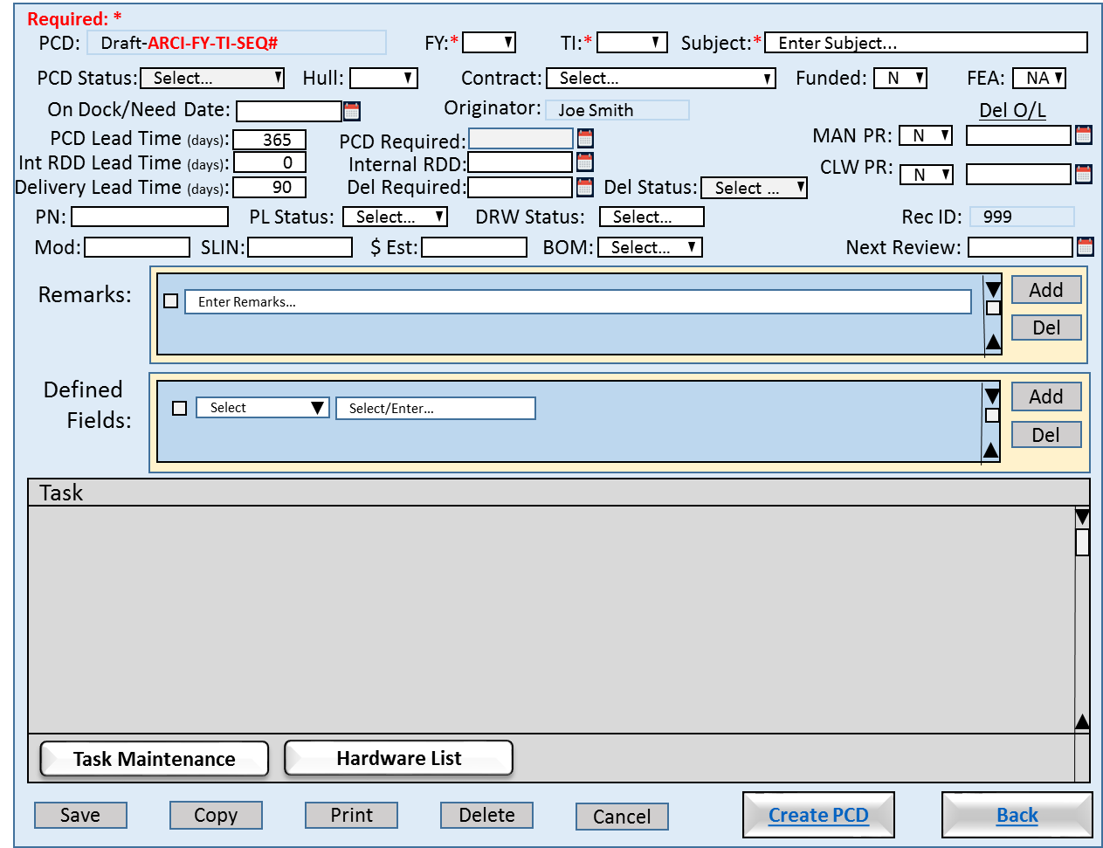

Figure 2‑3: PCD Tracker Entry (Blank)

* Save: Allows the user to save their changes made to the tracker entry. The system will trigger the creation of a required audit records. “Task Maintenance” and “Hardware List” have their own save functions.
* Copy: Allows the user to select an existing tracker entry and use it to pre-populate a new entry. The system will include all associated task data. (Need a save as function. The user would need to change either FY, TI or Subject to prevent a duplicate entry error.)
* Print: Allows the user to view a printer ready version of the PCD, and print the PCD.
* Delete: Allows the user to delete the “draft” PCD. The system will flag the entry as deleted and hide the entry from most searches, but the record will be retained by the system for audit purposes.
* Cancel: Allows the user to reset the view to the values at existed upon open the HMI.
* Create PCD: Allows the user to generate a PCD using the data entry into and/or associated with the tracker entry. Upon the initial generation the system will use all data associated with the entry. If the user choose the exclude tasks, remarks, attachments, etc. from the draft PCD, the system will flag those items from future re-generations of the PCD. (So we need a function to add them back in?) The system will trigger the creation of required audit records. The system will open the “PCD” view upon completion.
* Back: Returns to the “PCD Status View”.

##### Requirements

1. The system will all the <users> to add, update and remove <tasks>.
2. The system will allow only the <authorized users> to add and/or delete <remarks>.
3. The system will allow the <users> to copy an existing <tracker> into a new <tracker>.
4. The system will allow the <users> to generate a <draft PCD> from the related <tasks>.
5. The system will show the status of the PCD.
6. The system will allow the <user> to view all the tasks the have been assigned to the <tracker>.
7. The system will allow only the <authorized users> to edit and/or delete a <tracker>.
8. Upon delete of a <remark> the system will flag the <remark> record as logically deleted.
9. Upon delete of a <defined field> the system will flag the <defined field> record as logically deleted.
10. Upon delete of a <hardware list> the system will flag the <hardware list> record as logically deleted

##### Business Rules

* The date required can be no early than the current date.
* When a new <PCD> is requested the <PCD identifier> is populated with a <draft PCD identifier>.
* The <draft PCD identifier> will be updated with <PCD> identifier upon <PCD> approval.
* The <PCD status> will default to ?????.
* The <FY> is a required field and will default to blank.
* The <FY> will be selected from the active values contained in the <FY> enumeration list.
* The <TI> is a required field and will default to blank.
* The <TI> will be selected from the active values contained in the <TI> enumeration list.
* The <subject> is a required field and will default to “Enter Subject…”.
* The <subject> will accept any string except “Enter Subject…” as valid input.
* The <hull> will default to blank.
* The <hull> will be selected from the active values contained in the <hull> enumeration list.
* The <contract> will default to <blank>.
* The <contract> will be selected from the active values contained in the <contract> enumeration list.
* The <funded> will default to "N" until selected by the <project manager>.
* The <fea> identifier will default to "NA" until selected by the <project manager>.
* The <contract> is a required field and will default to <blank>.
* The <originator> will default to the individual who created the <draft PCD>.
* The <on dock/need date> will default to <blank> until entered by the <project manager>.
* The default <PCD lead time> is 365.
* Upon modification of the <PCD required date> by the user the system will recalculate the <PCD lead time>.
* The <PCD lead time> will greater than or equal to 0.
* The <PCD lead time> will validated against the active values contained in the <PCD lead time> enumeration list. Non-standard values will be confirmed with the user.
* The <PCD required date> default value is <on dock/need date> minus <PCD lead time>.
* The default <delivery lead time> is 90.
* Upon modification of the <delivery required date> by the user the system will recalculate the <delivery lead time>.
* The <delivery lead time> will greater than or equal to 0.
* The <delivery lead time> will validated against the active values contained in the <delivery lead time> enumeration list. Non-standard values will be confirmed with the user.
* The <delivery required date> default value is <on dock/need date> minus <delivery lead time>.
* The default <internal lead time> is 0.
* Upon modification of the < internal required date> by the user the system will recalculate the <internal lead time>.
* The <PCD rdd> cannot be later than or the same as the <internal rdd>.
* The <internal rdd> date cannot be later than or the same as the <on dock/need date>.
* The <internal rdd> identifier will default to <blank> until entered by the <project manager>.
* The < internal rdd > default value is <on dock/need date> minus < internal lead time>.
* The <man pr> Manassas purchase requisition default is false.
* The <man del o/l> Manassas delivery date outlook is blank.
* The <clw pr> Clearwater purchase requisition default is false.
* The <clw del o/l> Clearwater delivery date outlook is blank.
* The <pn> will
* The <pl status> identifier will default to <blank> until selected by the <project manager>. Enumeration Type: Approval (blank, Pre-Release, Released)
* The <dwg status> identifier will default to <blank> until selected by the <project manager>. Enumeration Type: Approval (blank, Pre-Release, Released)
* The <mod> identifier will default to <blank> until selected by the <project manager>.
* The <slin> identifier will default to <blank> until entered by the <project manager>.
* The <$est> will default to <blank> until entered by the <project manager>.
* The <bom> identifier will default to <blank> until selected by the <project manager>. Enumeration Type: Approval (blank, Pre-Release, Released)
* The <rec id>
* The <next review>

#### PCD Tracker Entry (Populated)

This is the “PCD Tracker Data View” HMI. When the user clicked on the hyperlink in the “PCD Status View” HMI the system open this view for the user. The view contains all the information displayed in the status row. (See PCD Tracker Entry for more details.)

When the user edits a “remark” a audit record will be generated.

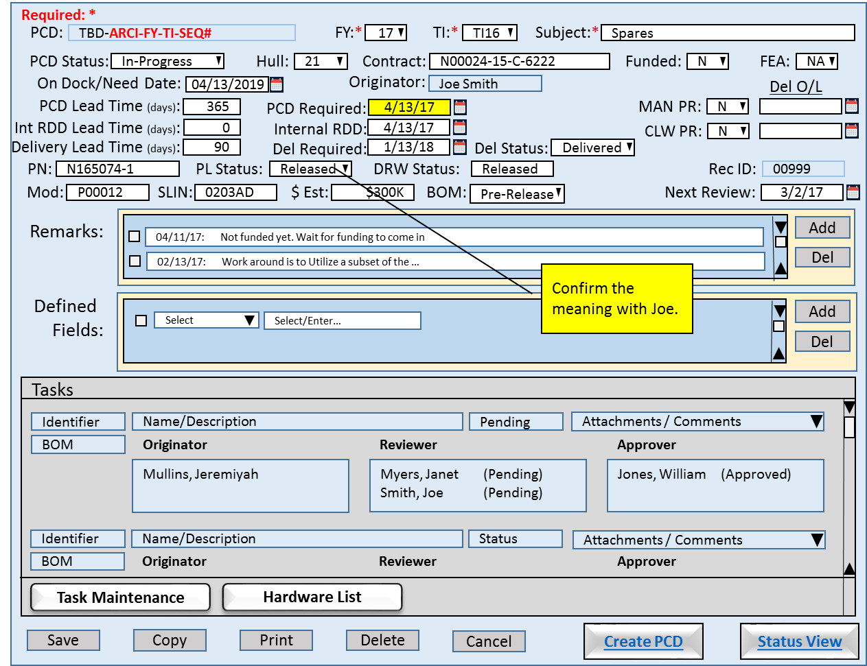

Figure 2‑4: PCD Tracker Entry (Populated)

#### Requirements

1. The system will allow the user to save the data to Excel.
2. The system will allow the user to print the data.

#### Business Rules

### Functions

1. Contract Selector
2. Enumeration Helper
3. Calendar

### Data Objects

1. Table 6‑2: Trackers
2. Table 6‑3: Program Control Directives (PCD)
3. Table 6‑7: Remarks
4. Table 6‑9: Contracts

### Enumerations

* FY
* TI
* PCD Status
* Hull
* Contract
* T/F (Funded, MAN PR, CLW PR)
* FEA
* Users (originator)
* Status Delivery Part Number
* Part List Status
* Drawing Status
* Mod
* SLIN
* BOM
* Defined Fields
* Task Type (blank, PN, DWG, DOM, PCD, PR)

### Complexity

|  | Count |
| --- | --- |
| Inputs | 18 |
| Outputs | 3 |
| Inquires | 4 |
| Files/Tables | 8 |
| Ext. Files | 0 |
| Total: | 33 |

## PCD Tracker Maintenance

The HMI will allow the authorized user to add, update, delete, and close tasks. The user will entered the required minimum information for the task type. The user can add and/or delete attachments and remarks regarding the activity from this HMI. These remarks will be included in the draft PCD where the user can choose to exclude the remarks from the PCD submission. The HMI contains a scrolled task panel that displays tasks already entered for the associated tracker entry. When the user selects a existing tasks by checking the tack, and clicking on the “Edit” button the this will populate the entry/edit form on the top of the page.

For the originator, reviewer, and approver inputs, the system will display a list of individuals where the user can select one or more individuals to add them to role.

The user can add attachments to the task by clicking on the “Add” button. The system will open a separate window where the user will search for and select the external file from. When the user selects a attachment(s) using the check box, the “View” and “Delete” buttons will be enabled. (The check box default state is unchecked.) When the “View” button is clicked the system will open a separate window and display the document. When the “Delete” button is clicked the system will remove the attachment(s) from the task. The attachment entry will be retained by the system with a “hidden” status for audit purposes. These attachment(s) will be included in the draft PCD where the user can choose to exclude the attachment(s) from the PCD submission.

The user can add and/or delete remarks regarding the task from this HMI. When the user selects a remark(s) using the check box, “Delete” buttons will be enabled. (The check box default state is unchecked.) When the “Delete” button is clicked the system will remove the remark(s) from the task. The remark entry will be retained by the system with a “hidden” status for audit purposes. These remark(s) will be included in the draft PCD where the user can choose to exclude the remark(s) from the PCD submission.

### Human Machine Interfaces

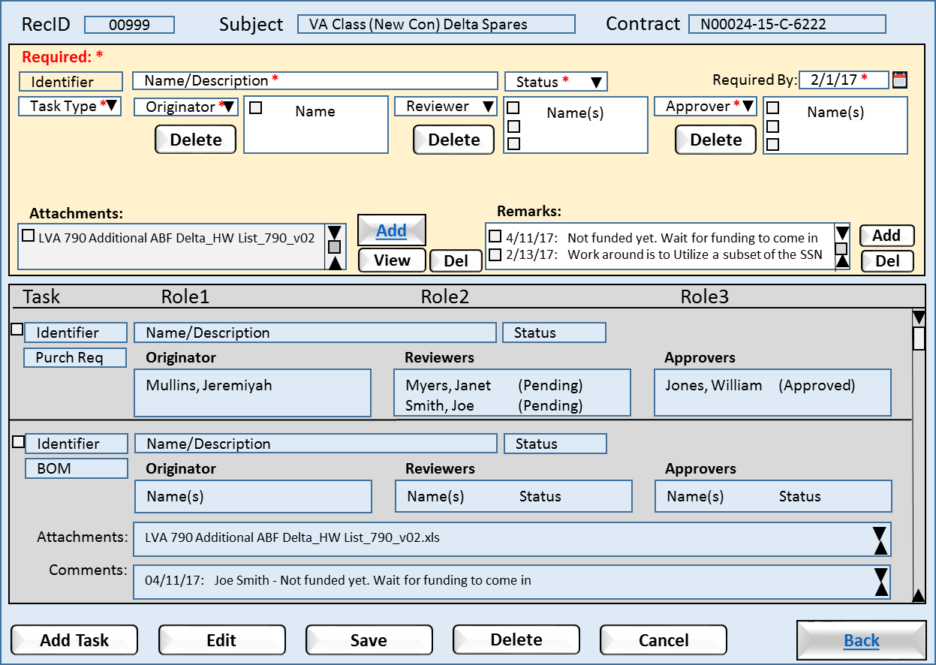

Figure 2‑5: PCD Tracker Maintenance

* Add: For the attachments it allows the user to attach a external document for the task.
* Delete: For the originator, reviewer, and approver roles, allows the user to remove an individual from the role for the task.
* View: For the attachments it allows the user to view the attachment selected.
* Delete: For the attachments and remarks fields, allows the user to remove elected items from the task.
* Add Task: Allows the user to enter a new task under the tracker entry. The system will initialize the input panel to its default state. The system will enable the “Save” button when all the required fields are entered.
* Edit: When the user selects a task from the task panel the system will enable the “Edit” button. When the user clicks the “Edit” button the system will populate the task edit panel and the allow user to update the task.
* Save: Allows the user to save their changes made to the task entry. The system will trigger the creation of required audit records. “Task Maintenance” and “Hardware List” have their own save functions. (Audit details)
* Delete: Allows the user to delete the “draft” PCD. The system will flag the entry as deleted and hide the entry from most searches, but the record will be retained by the system for audit purposes.
* Cancel: Allows the user to reset the view to the values at existed upon open the HMI.
* Back: Returns the user to the HMI that the current HMI was called from.

### Requirements

1. The system shall automatically assign item identifiers that are unique.
2. The system shall validate that all required fields are complete.
3. The system shall allow the <authorized user> to maintain the enumerations used in the drop-down list boxes.
4. The system shall use the <active directory> to assign individual tasks.

### Business Rules

1. A required roles needs to have at least one individual assigned.
2. The <Required By> date cannot be later than or the same as the <Internal RDD> date.

### Functions

1. Calendar
2. Action Person Helper
3. Approver Person Helper
4. Enumeration Helper
5. Attachments
6. Notes?

### Data Objects

* Table 6‑2: Trackers
* Table 6‑3: Program Control Directives (PCD)
* Table 6‑7: Remarks
* Table 6‑8: Tasks
* Table 6‑11: Attachments
* Table 6‑12: Enumeration Values

### Enumerations

1. Status Tracker
2. Task Type
3. Users (Originator, Reviewers, Approvers)

### Complexity

|  | Count |
| --- | --- |
| Inputs | 11 |
| Outputs | 1 |
| Inquires | 7 |
| Files/Tables | 6 |
| Ext. Files | 1 |
| Total: | 26 |

## PCD Hardware List Entry

This HMI allows the user to construct a hardware list. The basic HMI has three inputs:

* The hardware list
* Remarks
* Attachments

The four buttons on the bottom of the HMI permit the user to save a list being work, submit for approval, or cancel any changes that had been contacts, or remarks.

When the user has prepared the hardware list outside the PCD, the user will import the external document as an attachment(s).

The panel in the center of the HMI is where the user constructs the hardware list. When the HMI opens any parts previously entered would be displayed. When the user clicks on the Add button a new line will be created for the user to complete. When the Add button is clicked any changes/additions to the list will saved. When a value has been entered into a new line the “Save” button will be enabled.

If the user needs to delete a line(s), the user would select the line(s) and then click the Delete button. Until user selects a hardware list entry the “Delete” button would be disabled.

The select of a hardware list entry or entries will enable the “Group By” button. The “Group By” allows the user to assign an identifier to those entries. As shown in the HMI the user select the “sonar laptop” entry and assigned it to the “Hardware” group, and repeated the action to create a “Software” group. Does the group need a checkbox? The HMI will refresh to reflect the user grouping automatically. To remove a hardware list entry from a group the user would select the entry and assign it to the “” group which is the default group for all entries.

Cancel?

### Human Machine Interfaces

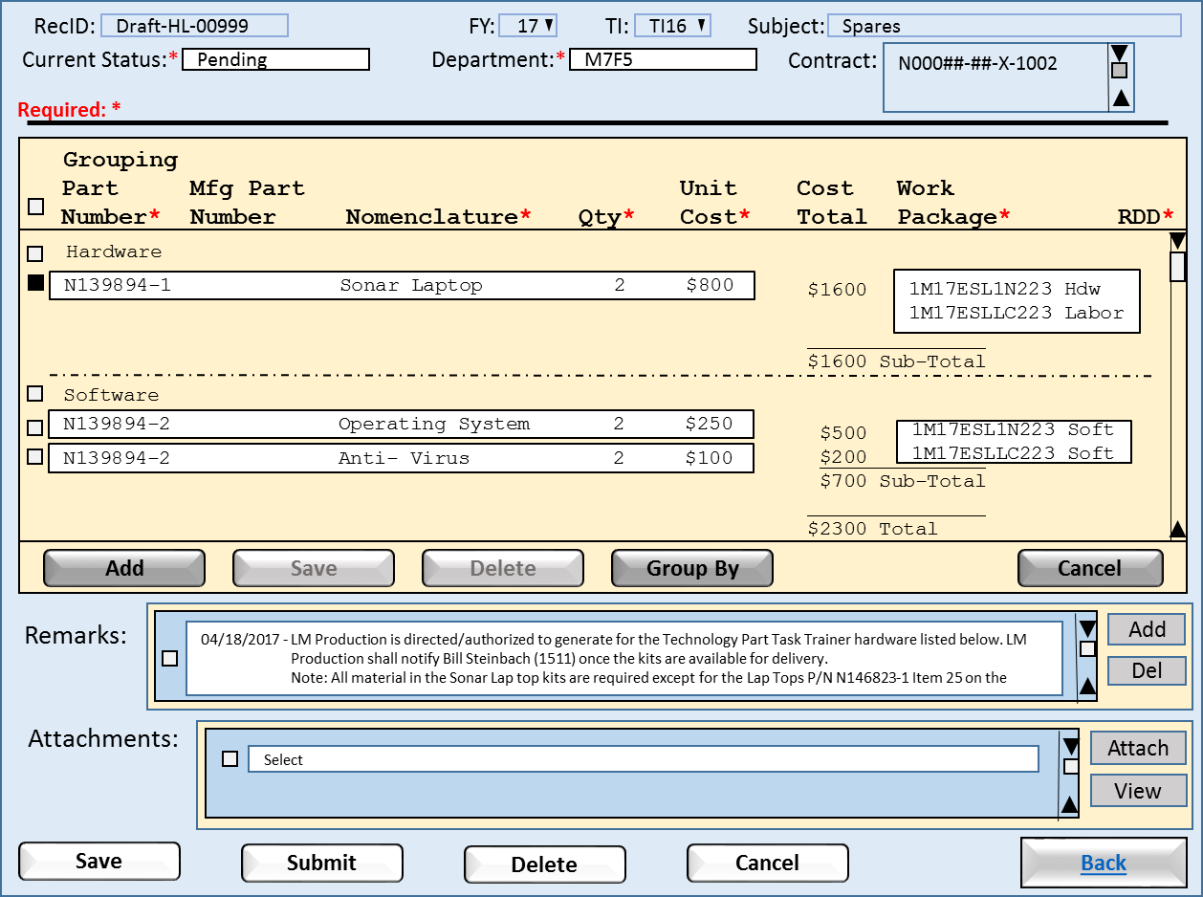

Figure 2‑6: PCD Hardware Entry List

* Add: The system will add a blank line item for the user to complete.
* Save: Allows the user to save an added or updated line item.
* Delete: The system will delete those line item(s) the user has selected for removal. (Audit details)
* Group By: The system will group line item(s) the user has selected. (How do we ungrouped items?)
* Cancel: Allows the user to reset the line items to the values at existed upon open the HMI.
* Save: Allows the user to save their changes made to the task entry. The system will trigger the creation of required audit records. “Task Maintenance” and “Hardware List” have their own save functions. (Audit details)
* Submit: Allows the user to submit the hardware list for review.
* Delete: Allows the user to delete the “draft” hardware list. The system will flag the entry as deleted and hide the entry from most searches, but the record will be retained by the system for audit purposes.
* Cancel: Allows the user to reset the view to the values at existed upon open the HMI.
* Back: Returns the user to the HMI that the current HMI was called from.

### Requirements

1. Upon saving of the hardware List entry, the system will check for empty/null required fields and if found the system will prompt the user to completed entry of required fields.
2. If unsaved changes exist prior to closing the HMI, the system will prompt the user to save the changes.
3. If unsaved changes exist prior to cancel a session, the system will warn the user that changes will be lost.
4. Before deleting a part(s) the system will prompt the user for confirmation.

### Business Rules

1. The Submit button will be enabled when either one part is added, or a attachment has been made.
2. When the Submit button is clicked the system will forwarded the to the reviewers/approvers.
3. When all the reviewers/approves have approved the hardware list, the list will be forwarded to the purchasing contacts.
4. An approved Hardware List will be locked to prevent additional part list changes.
5. An approved Hardware List will need approver to submit the part list for rework for changes to be made to the part list.
6. ??? Change history

### Functions

1. Directory Helper
2. Attachments
3. Remarks
4. Hardware List

### Data Objects

* Table 6‑4: Hardware Lists
* Table 6‑5: Hardware List Items
* Table 6‑6: Remarks
* Table 6‑7: Tasks
* Table 6‑11: Attachments

### Enumerations

1. Status Hardware List
2. Departments

### Complexity

|  | Count |
| --- | --- |
| Inputs | 10 |
| Outputs | 3 |
| Inquires | 1 |
| Files/Tables | 3 |
| Ext. Files | 1 |
| Total: | 18 |

## PCD Draft

This HMI shows the results of the user from having clicked the “Create PCD” button on the “PCD Tracker Entry” HMI. The data elements from all PCD tasks combined together in their respective sections. This the last sentence true, or is select sections? The HMI includes the functionality for the user to be able expand/collapse any given section. All the section are collapse when HMI opens. The user can click on the “+” symbol to expand a section. The section will resize the section and page to fit the data elements. The “+” symbol will change to a “-” symbol. Clicking a “-” will collapse the section and resize page. Should the user choose to add a data element to a section that is collapsed, the section will automatically expand.

The user has the functionality to edit each of the sections prior to the PCD submission. When the HMI opens only the “Add” buttons will be enabled. Depending on the section, when a data element is selected by the user using the checkbox the “Delete” and “View” are enabled. Deselecting the data element disable the buttons.

### Human Machine Interfaces

#### PCD Draft (Collapsed)

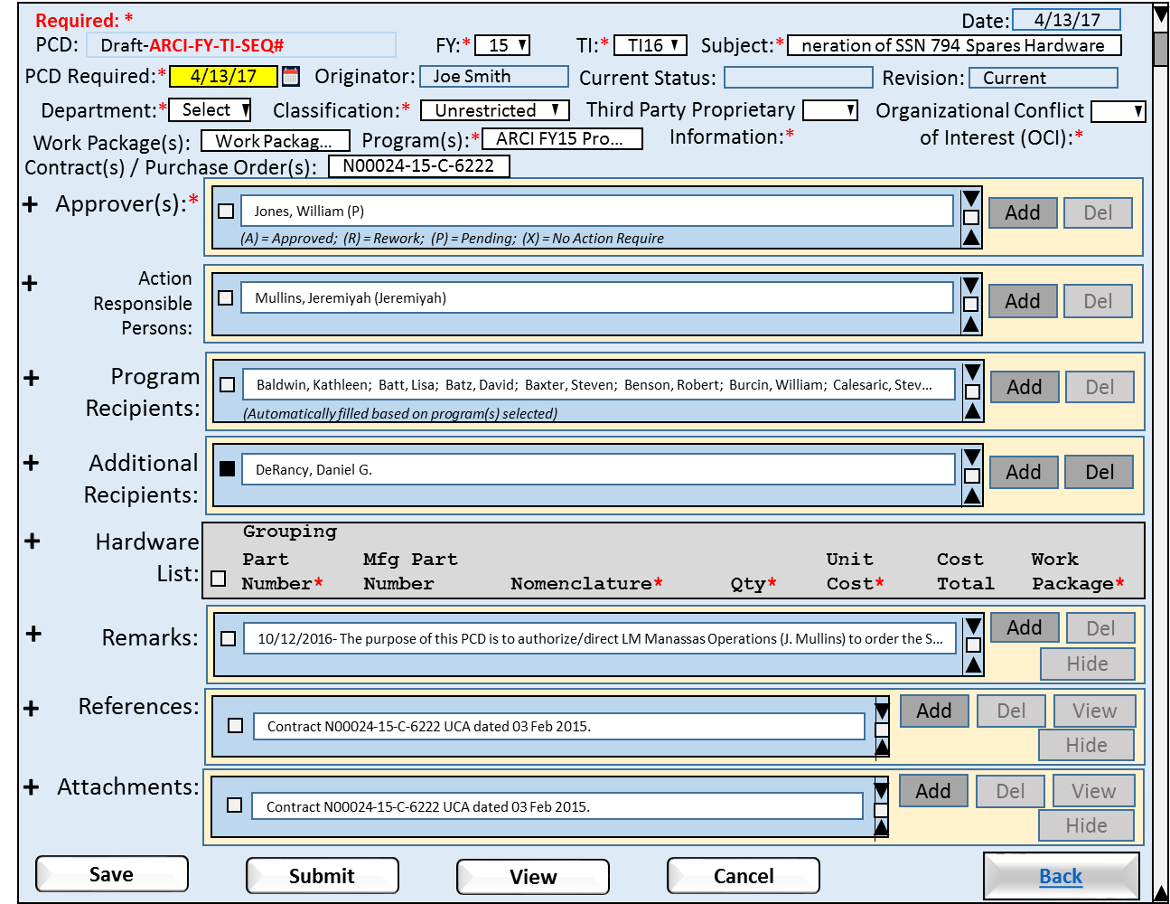

Figure 2‑7: PCD Draft (Collapsed)

* Add: Allows the user to insert additional items into the PCD.
* Delete:
* View: For the attachments it allows the user to view the attachment selected.
* Hide/Unhide:
* Save: Allows the user to save their changes made to the task entry. The system will trigger the creation of required audit records. “Task Maintenance” and “Hardware List” have their own save functions. (Audit details)
* Submit: Allows the user to submit the PCD for review.
* View: Allows the preview how the PCD will look when printed.
* Cancel: Allows the user to reset the line items to the values at existed upon open the HMI.
* Back: Returns to the “PCD Status View”.

##### Requirements

1. The system will allow the user to collapse a expanded section.
2. The system will allow the user to expand a collapsed section.
3. The system will allow the user to collapse all sections with a single click.
4. The system will allow the user to expand all sections with a single click.
5. If unsaved changes exist prior to closing the HMI, the system will prompt the user to save the changes.
6. If unsaved changes exist prior to cancel a session, the system will warn the user that changes will be lost.

##### Business Rules

1. Upon the user adding a new data element to a section the System will associate and stored the data element with PCD.
2. Upon user change to an existing element in a section the System will update the source data element in the respective section and task.
3. Upon clicking the “Submit” button the system will change the PCD status from “Draft” to “Submitted”.
4. Upon clicking the “Submit” button the system will notify the reviewer(s)/approver(s) that the PCD is available for review.

#### PCD Draft (Expanded I)

In this view of the “Draft PCD” HMI shows all the sections expanded. The page size will automatically expand to fit the data elements.

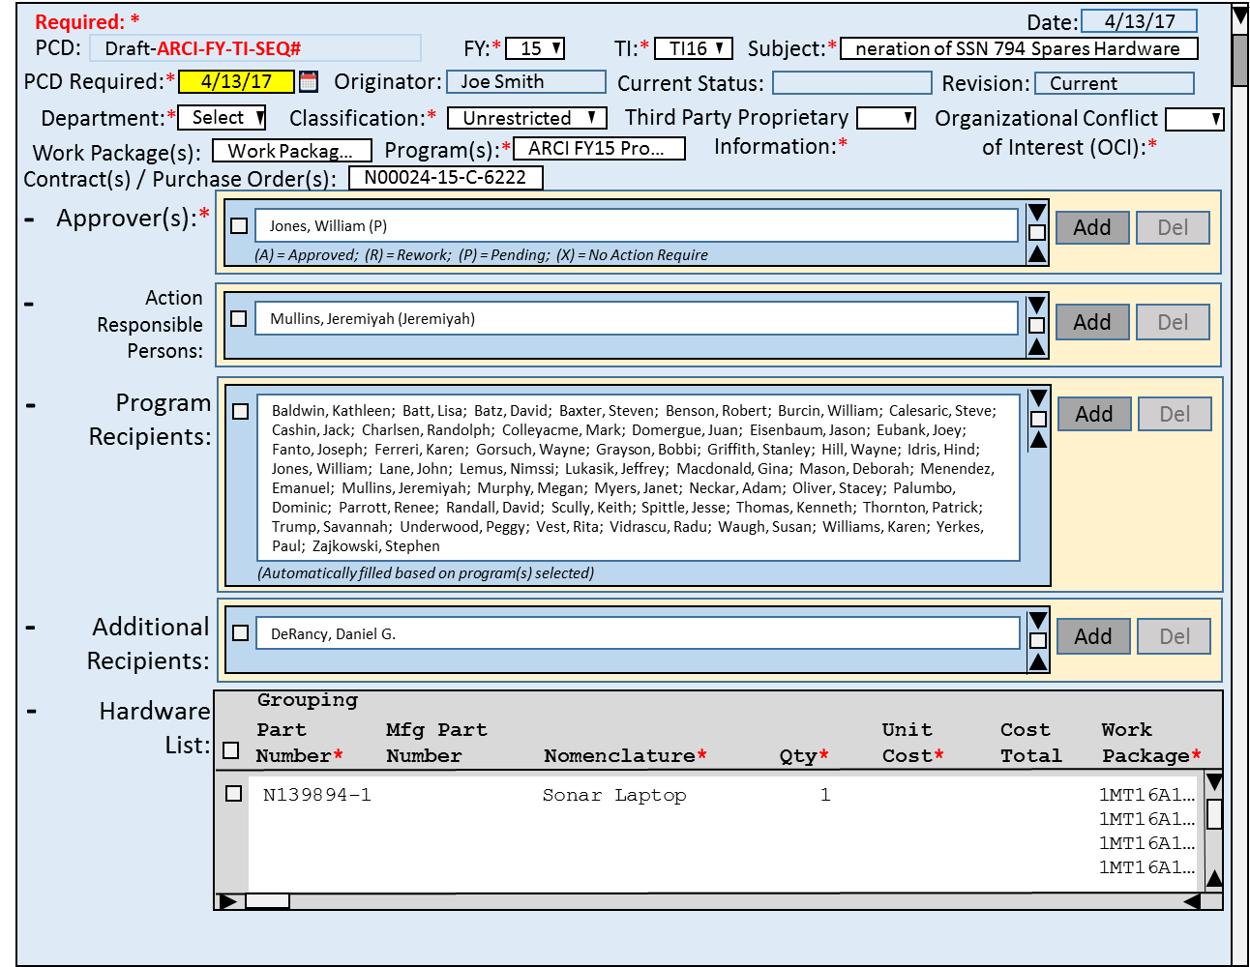

Figure 2‑8: PCD Draft (Expanded I)

##### Requirements

1. If unsaved changes exist prior to closing the HMI, the system will prompt the user to save the changes.
2. If unsaved changes exist prior to cancel a session, the system will warn the user that changes will be lost.

##### Business Rules

1. The Submit button will be enabled when either one part is added, or a attachment has been made.
2. When the Submit button is clicked the system will forwarded the to the reviewers/approvers.
3. When all the reviewers/approves have approved the hardware list, the list will be forwarded to the purchasing contacts.
4. An approved Hardware List will be locked to prevent additional part list changes.
5. An approved Hardware List will need approver to submit the part list for rework for changes to be made to the part list.
6. ??? Change history

#### PCD Draft (Expanded II)

This version of the Draft PCD includes the user functionality to include/exclude data elements within a section from the PCD submission. In the “Remarks” section the user has previously choose the exclude the remark dated 8/19/2015. The HMI indicates that the remark is excluded by graying out the data item display. This tells the user that the remark will excluded from the submitted PCD. Because the remark is excluded and the selection box checked the “Unhide” button is enabled to allow the user to be able to add the remark back into the PCD.

In comparison the “References” section has an item that is selected and the “Hide” button enabled. This allows the user to exclude this item from the PCD if they choose. If the wishes choose to hide the item they would do so by clicking on the “Hide” button, the item would be grayed as show above with the remarks item.

If the user were to alter a “Remark”, the alteration would trigger the creation of a audit record capturing the remark’s pre and post content.

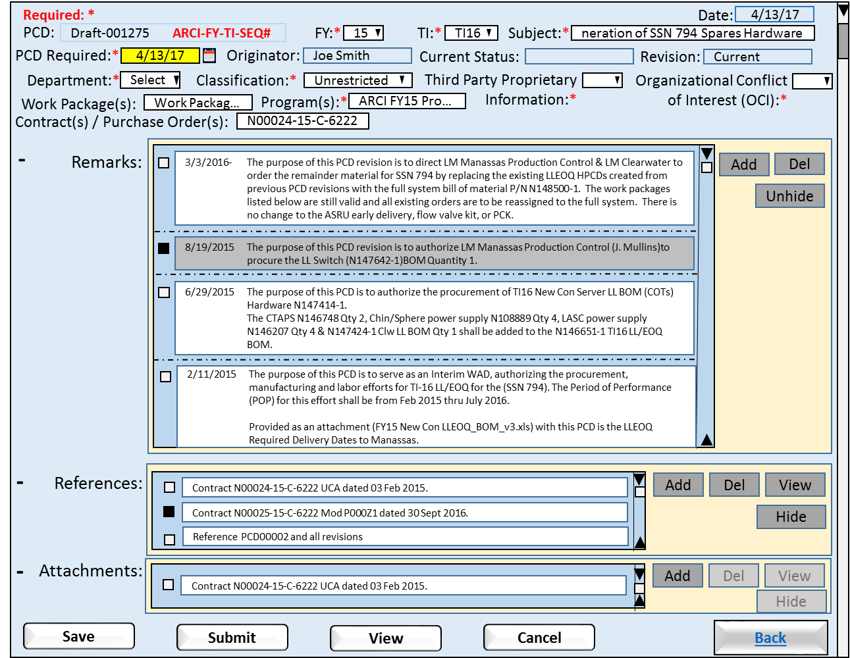

Figure 2‑9: PCD Draft (Expanded II)

##### Requirements

1. The system will allow the user to select data items to be include/excluded from the PCD submission.
2. The system will gray out excluded items.
3. If unsaved changes exist prior to closing the HMI, the system will prompt the user to save the changes.
4. If unsaved changes exist prior to cancel a session, the system will warn the user that changes will be lost.

##### Business Rules

1. The Submit button will be enabled when either one part is added, or a attachment has been made.
2. When the Submit button is clicked the system will forwarded the to the reviewers/approvers.
3. When all the reviewers/approves have approved the hardware list, the list will be forwarded to the purchasing contacts.
4. An approved Hardware List will be locked to prevent additional part list changes.
5. An approved Hardware List will need approver to submit the part list for rework for changes to be made to the part list.
6. ??? Change history

### Functions

1. Directory Helper
2. Attachments
3. Remarks
4. Hardware List

### Data Objects

1. Table 6‑2: Trackers
2. Table 6‑3: Program Control Directives (PCD)
3. Table 6‑4: Hardware Lists
4. Table 6‑5: Hardware List Items
5. Table 6‑6: Remarks
6. Table 6‑11: Attachments

### Enumerations

* Users

### Complexity

|  | Count |
| --- | --- |
| Inputs | 0 |
| Outputs | 0 |
| Inquires | 0 |
| Files/Tables | 0 |
| Ext. Files | 0 |
| Total: | 0 |

## PCD Entry

This HMI is intended for the entry of a simple PCDs such as a Delegation of Authority, (DOA). The user will have selected to create a new PCD from the “PCD Status Review” HMI. The “Originator” field will be pre-filled with the id of the individual who clicked the “New PCD” button. The “Add” functions will be the only data entry functions enabled. Once the user was populated a field the “Save” button will be enabled. Once the user was populated the required fields the “Submit”, and “View” buttons will be enabled.

After adding a value to “Approver(s)” section and checking the selection box, the “Delete” function would be enabled. If the user unchecked the selection, or did delete the selection, the “Delete” function would be disabled. The same controls would apply to the sections: Program Recipients, Action Responsible Persons, Additional Recipients, Hardware List, and Remarks. In case of References and Attachments, the “View” function would work in the same fashion as the “Delete” function.

### Human Machine Interfaces

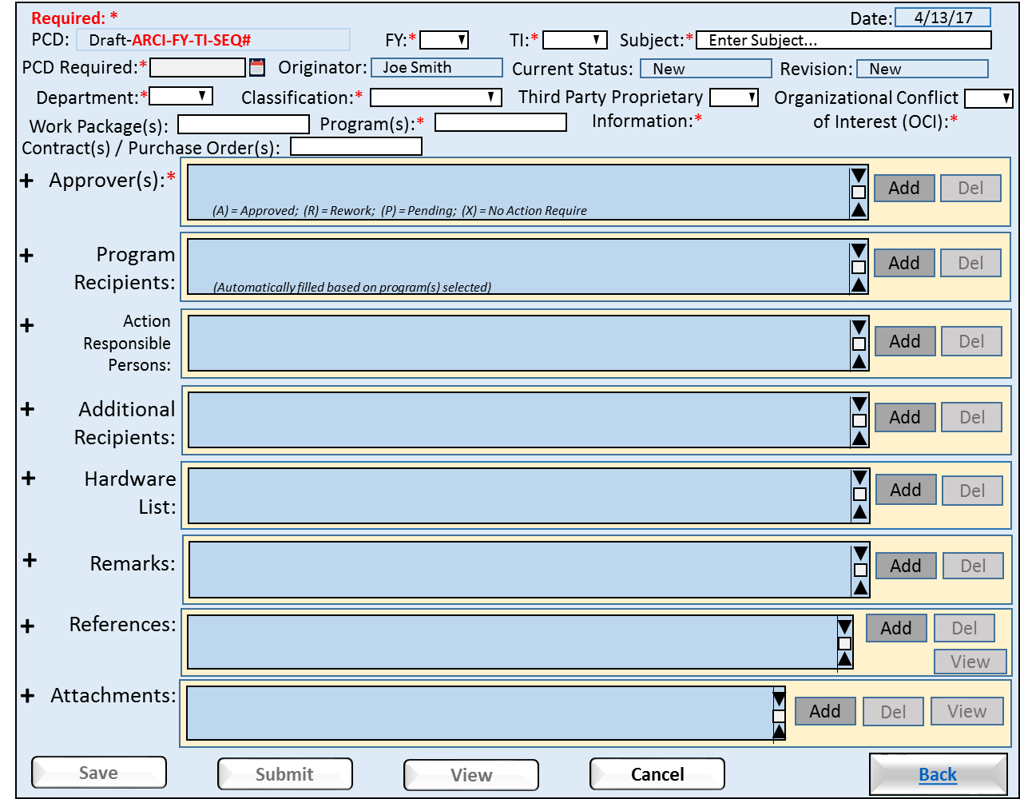

Figure 2‑10: PCD Entry

* Save: Allows the user to save their changes made to the task entry. The system will trigger the creation of required audit records. “Task Maintenance” and “Hardware List” have their own save functions. (Audit details)
* Submit: Allows the user to submit the PCD for review.
* View: Allows the preview how the PCD will look when printed.
* Cancel: Allows the user to reset the line items to the values at existed upon open the HMI.
* Back: Returns to the “PCD Status View”.

### Requirements

1. Upon submission of the PCD the system will check for empty/null required fields and if found the system will prompt the user to completed entry of required fields.
2. If unsaved changes exist prior to closing the HMI, the system will prompt the user to save the changes.
3. If unsaved changes exist prior to cancel a session, the system will warn the user that changes will be lost.

### Business Rules

1. The Save button will be enabled when at least one data field is filled, and disabled when no data fields are filled.
2. The Submit button will be enabled when the required fields are filled, and disabled when a required field(s) are empty/null.
3. When the Submit button is clicked the system will forwarded the to the reviewers/approvers for review.

### Functions

1. Directory Helper
2. Attachments
3. Remarks
4. Attachments

### Data Objects

* Table 6‑2: Trackers
* Table 6‑3: Program Control Directives (PCD)
* Table 6‑4: Hardware Lists
* Table 6‑5: Hardware List Items
* Table 6‑6: Remarks
* Table 6‑11: Attachments

### Enumerations

### Complexity

|  | Count |
| --- | --- |
| Inputs | 3 |
| Outputs | 1 |
| Inquires | 11 |
| Files/Tables | 6 |
| Ext. Files | 0 |
| Total: | 21 |

## PCD Generic View

All of the PCD data may be viewed. Attachments can be retrieved, however they cannot be added, modified, or deleted from the PCD itself. The PCD state cannot be changed.

### Human Machine Interfaces

#### (I)

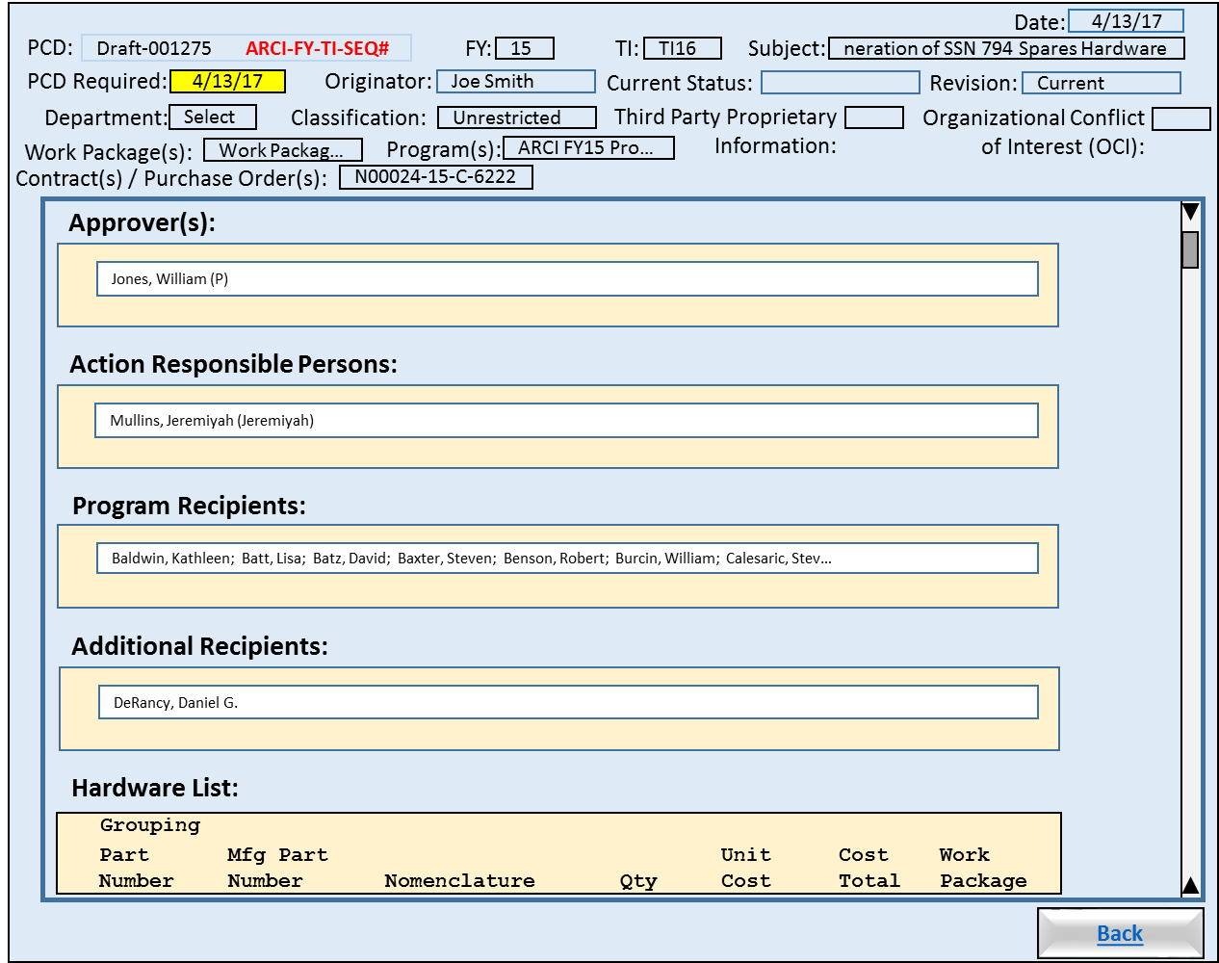

Figure 2‑11: PCD Generic View (I)

* Back: Returns to the “PCD Status View”.

##### Requirements

##### Business Rules

#### (II)

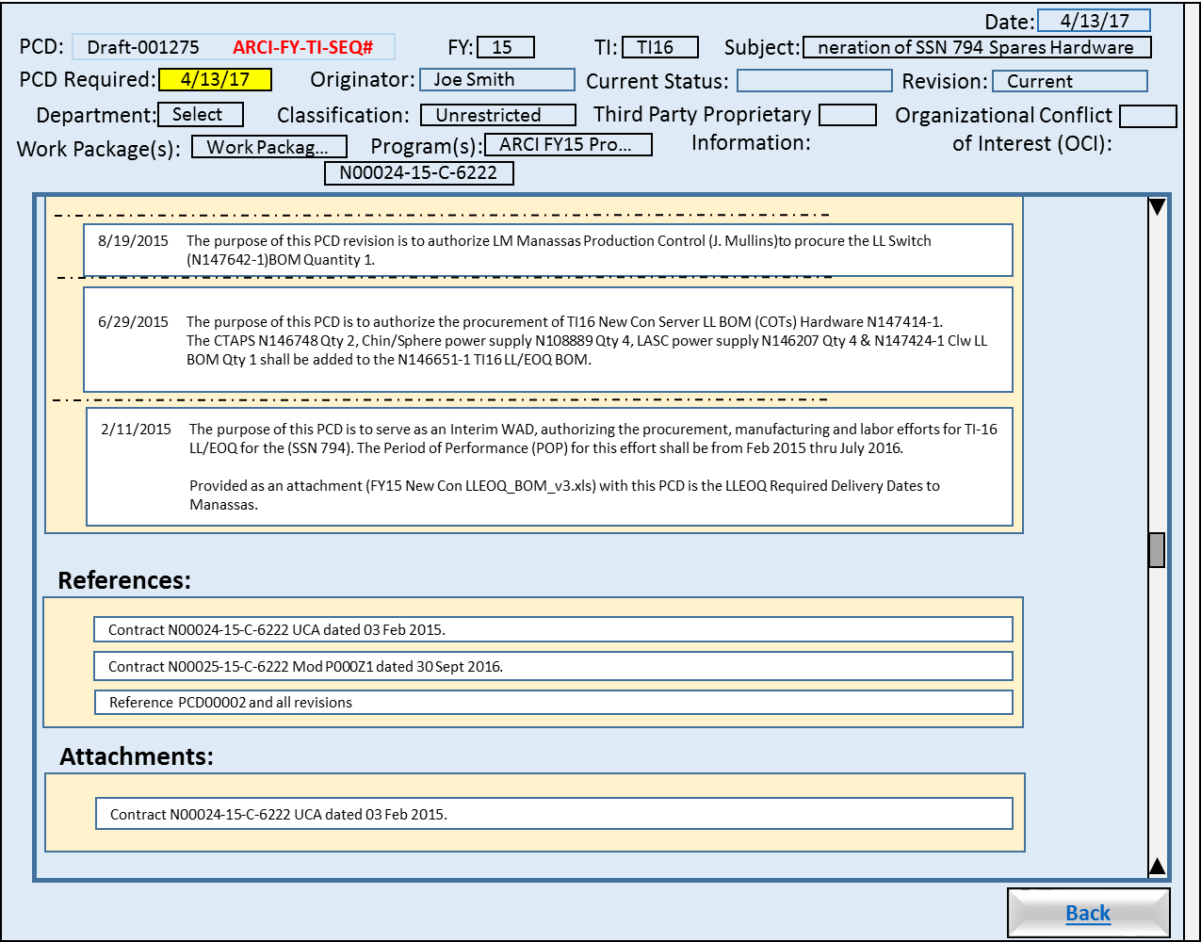

Figure 2‑12: PCD Generic View (II)

##### Requirements

##### Business Rules

#### Buttons







##### Requirements

##### Business Rules

### Views

### Functions

### Data Objects

* Table 6‑2: Trackers
* Table 6‑3: Program Control Directives (PCD)
* Table 6‑4: Hardware Lists
* Table 6‑5: Hardware List Items
* Table 6‑6: Remarks
* Table 6‑11: Attachments

### Enumerations

### Complexity

|  | Count |
| --- | --- |
| Inputs | 0 |
| Outputs | 0 |
| Inquires | 0 |
| Files/Tables | 0 |
| Ext. Files | 0 |
| Total: | 0 |

## [CSC Name] CSC

This section should start with a brief description of the CSC.

### [Function Name]

This section describes a function of the CSC. Each function allocated to the CSC should reside under its own heading, so there may be multiple sections. Test methods can be embedded within the descriptions. If so, place a note in section 2.4 that states the embedded approach.

#### Test Method

This section provides CQT level test description for the function described above.

#### Algorithms (if applicable)

This section should describe any algorithms needed for the SW team to implement.

#### SW Reuse (if applicable)

This section examines the proposed software reuse that was identified during the replan estimation process. (see Alan’s ppt at: <https://www.silcweb.com/silc/?u=bpw>).

#### Requirements Traceability

This section provides a traceability matrix for the SSS and PBS requirements related to the CSC specification.

# PCD Working Modes

The modes are available when working with an individual PCD: Edit, Approve, and View. When a PCD has been selected, the mode in which it’s displayed depends on its state and the authority of the current user. The application picks which mode to open the PCD in based upon the Conditions column of Table 2-1.

Table 2‑1: PCD Working Modes

| Mode | Conditions | Description |
| --- | --- | --- |
| Edit | Originator or Administrator when PCD is in Draft or Rework state. | Allows entry/modification of the following fields:   * Approver(s) * Associated Contracts * Department * Subject * Distribution Lists * Action Responsible People * Additional Recipients * Reference * Action/Remarks * Programs * Program to Use in PCD Number * Attachments   The PCD can be Saved, Submitted, or Deleted. |
| View | Any user and any PCD in any state (which is not listed for the Edit or Approve modes). | All of the PCD data may be viewed. Attachments can be retrieved, however they cannot be added, modified, or deleted from the PCD itself. The PCD state cannot be changed. |
| Approve | Assigned Approver when PCD is in Submitted state. | Approvers can view the PCD just as in the View mode. In addition they may add/modify their remarks and select to Approve or Rework the PCD. |

# Common Function

## Enumeration Helpers

### Human Machine Interfaces

#### Drop Down List Box

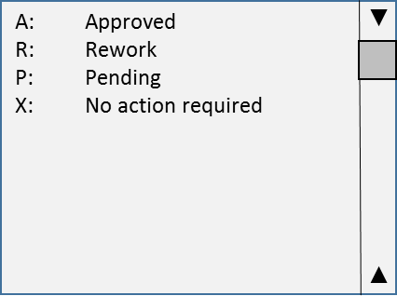

##### Requirements

##### Business Rules

#### Modal

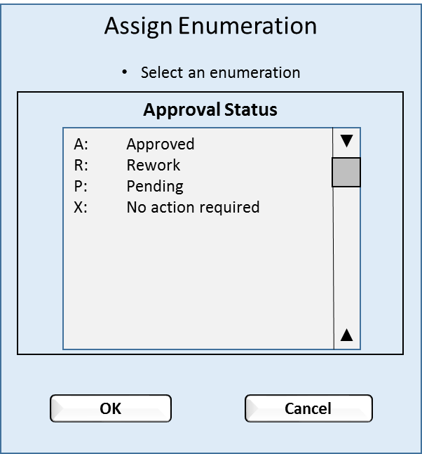

##### Requirements

##### Business Rules

### Views

### Functions

### Data Objects

### Enumerations

### Complexity

|  | Count |
| --- | --- |
| Inputs | 1 |
| Outputs | 0 |
| Inquires | 2 |
| Files/Tables | 2 |
| Ext. Files | 0 |
| Total: | 5 |

## Enumeration Types

### Human Machine Interfaces

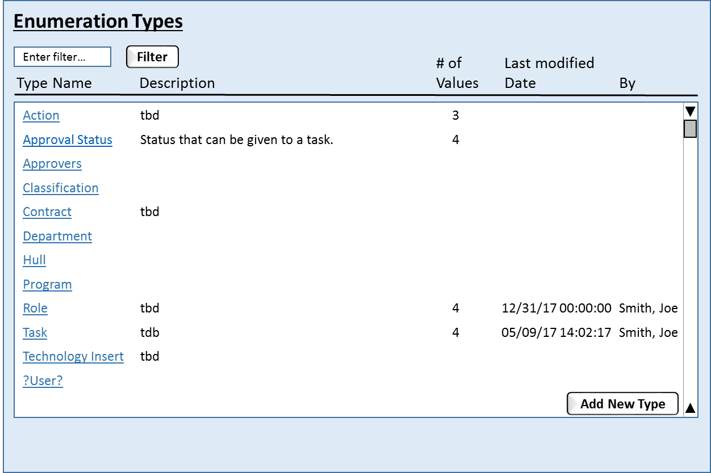

### Requirements

### Business Rules

### Views

### Functions

### Data Objects

### Enumerations

### Complexity

|  | Count |
| --- | --- |
| Inputs | 2 |
| Outputs | 1 |
| Inquires | 1 |
| Files/Tables | 1 |
| Ext. Files | 0 |
| Total: | 5 |

## Enumeration Values

### Human Machine Interfaces

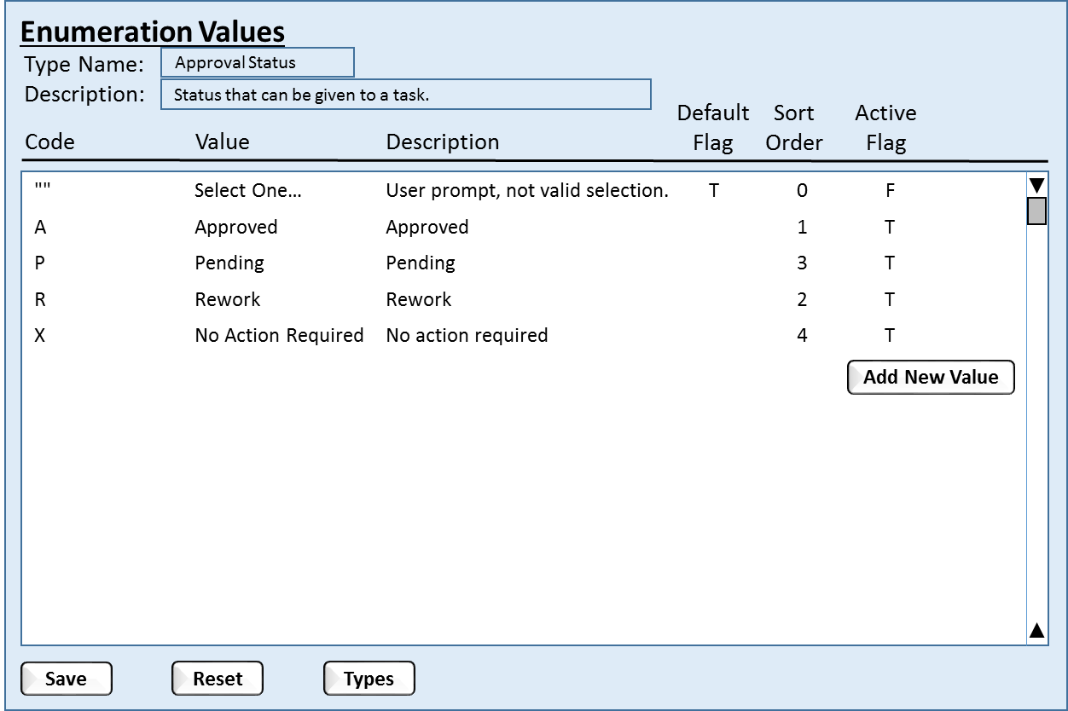

### Requirements

### Business Rules

### Views

### Functions

### Data Objects

### Enumerations

### Complexity

|  | Count |
| --- | --- |
| Inputs | 2 |
| Outputs | 1 |
| Inquires | 2 |
| Files/Tables | 2 |
| Ext. Files | 0 |
| Total: | 7 |

## Enumeration Value Associations

### Human Machine Interfaces

### Requirements

### Business Rules

### Views

### Functions

### Data Objects

### Enumerations

### Complexity

|  | Count |
| --- | --- |
| Inputs | 0 |
| Outputs | 0 |
| Inquires | 0 |
| Files/Tables | 0 |
| Ext. Files | 0 |
| Total: | 0 |

## Printable Version

### Human Machine Interfaces

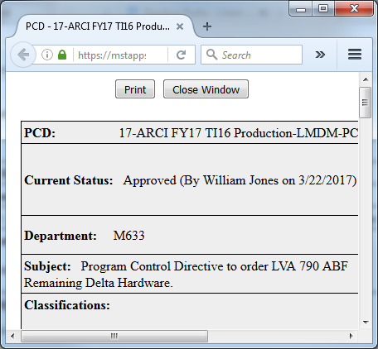

### Requirements

### Business Rules

### Views

### Functions

### Data Objects

### Enumerations

### Complexity

|  | Count |
| --- | --- |
| Inputs | 3 |
| Outputs | 0 |
| Inquires | 11 |
| Files/Tables | 6 |
| Ext. Files | 0 |
| Total: | 20 |

## Classification

### Human Machine Interfaces

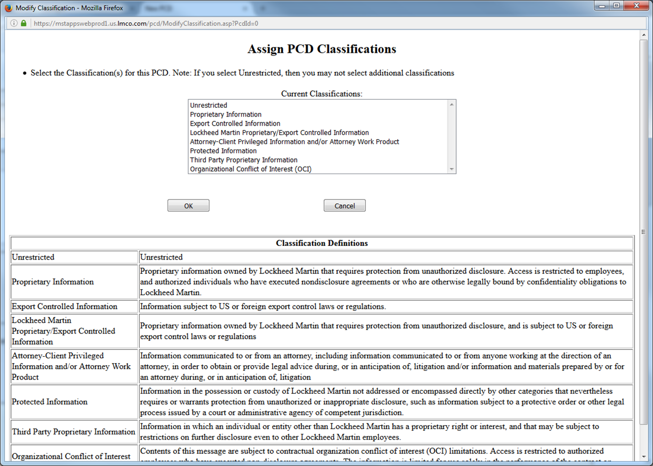

### Requirements

### Business Rules

### Views

### Functions

### Data Objects

### Enumerations

### Complexity

|  | Count |
| --- | --- |
| Inputs | 0 |
| Outputs | 0 |
| Inquires | 0 |
| Files/Tables | 0 |
| Ext. Files | 0 |
| Total: | 0 |

## Contracts / Purchase Order(s)

### Human Machine Interfaces

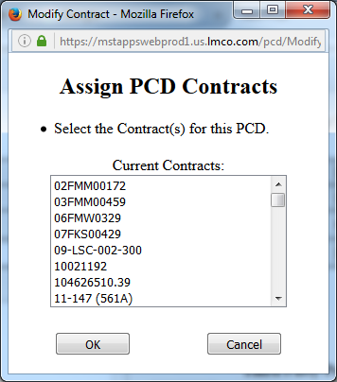

### Requirements

### Business Rules

### Views

### Functions

### Data Objects

### Enumerations

### Complexity

|  | Count |
| --- | --- |
| Inputs | 0 |
| Outputs | 0 |
| Inquires | 0 |
| Files/Tables | 0 |
| Ext. Files | 0 |
| Total: | 0 |

## Assign Approver(s)

### Human Machine Interfaces

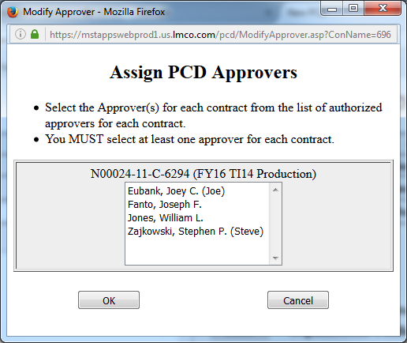

### Requirements

### Business Rules

### Views

### Functions

### Data Objects

### Enumerations

### Complexity

|  | Count |
| --- | --- |
| Inputs | 0 |
| Outputs | 0 |
| Inquires | 0 |
| Files/Tables | 0 |
| Ext. Files | 0 |
| Total: | 0 |

## Action Responsible Person(s) / Additional Resources

### Human Machine Interfaces

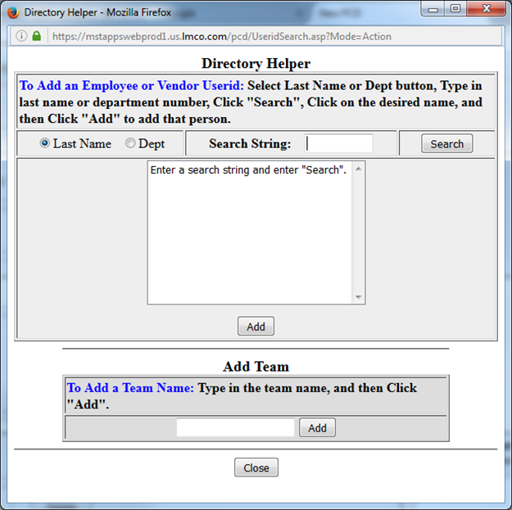

### Requirements

### Business Rules

### Views

### Functions

### Data Objects

### Enumerations

### Complexity

|  | Count |
| --- | --- |
| Inputs | 0 |
| Outputs | 0 |
| Inquires | 0 |
| Files/Tables | 0 |
| Ext. Files | 0 |
| Total: | 0 |

## Assign Programs

### Human Machine Interfaces

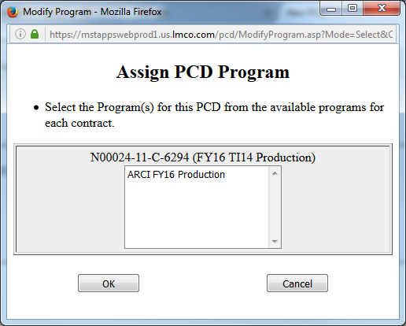

### Requirements

### Business Rules

### Views

### Functions

### Data Objects

### Enumerations

### Complexity

|  | Count |
| --- | --- |
| Inputs | 0 |
| Outputs | 0 |
| Inquires | 0 |
| Files/Tables | 0 |
| Ext. Files | 0 |
| Total: | 0 |

## Attachments

### Human Machine Interfaces

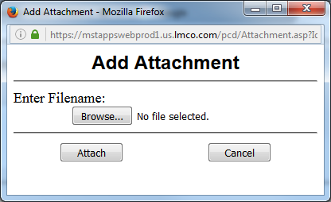

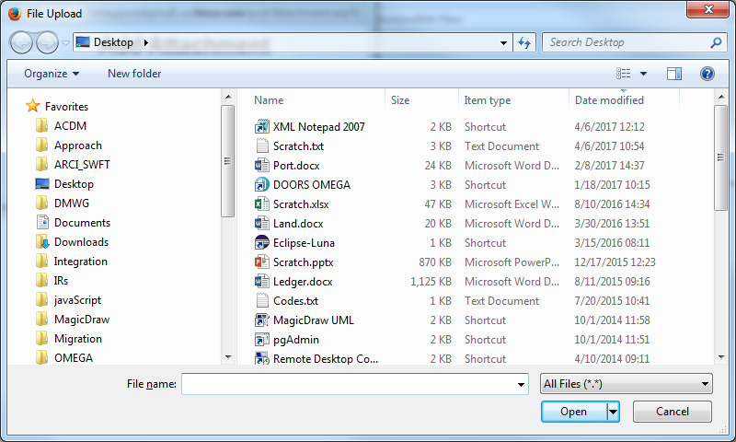

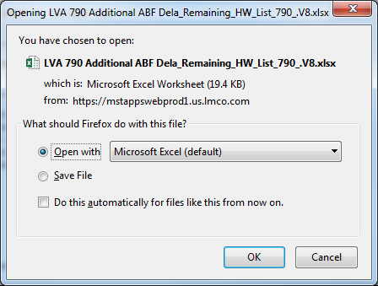

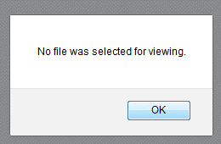

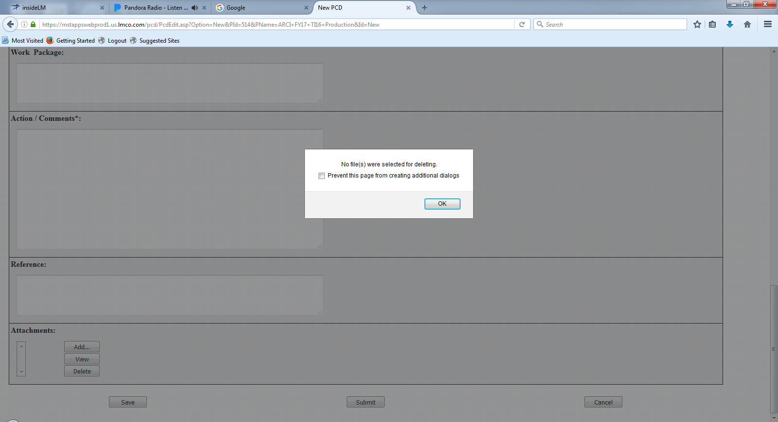

### Requirements

### Business Rules

### Views

### Functions

### Data Objects

### Enumerations

### Complexity

|  | Count |
| --- | --- |
| Inputs | 0 |
| Outputs | 0 |
| Inquires | 0 |
| Files/Tables | 0 |
| Ext. Files | 0 |
| Total: | 0 |

## PCD Notification

### Human Machine Interfaces

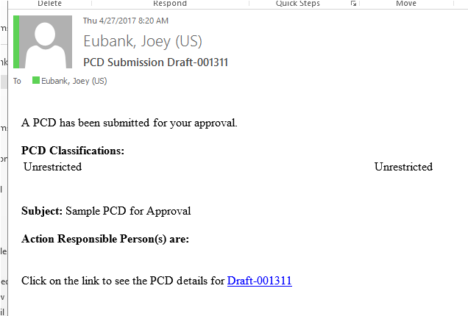

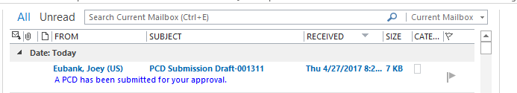

### Requirements

### Business Rules

### Views

### Functions

### Data Objects

### Enumerations

### Complexity

|  | Count |
| --- | --- |
| Inputs | 0 |
| Outputs | 0 |
| Inquires | 0 |
| Files/Tables | 0 |
| Ext. Files | 0 |
| Total: | 0 |

## PCD Users Guide

### Human Machine Interfaces

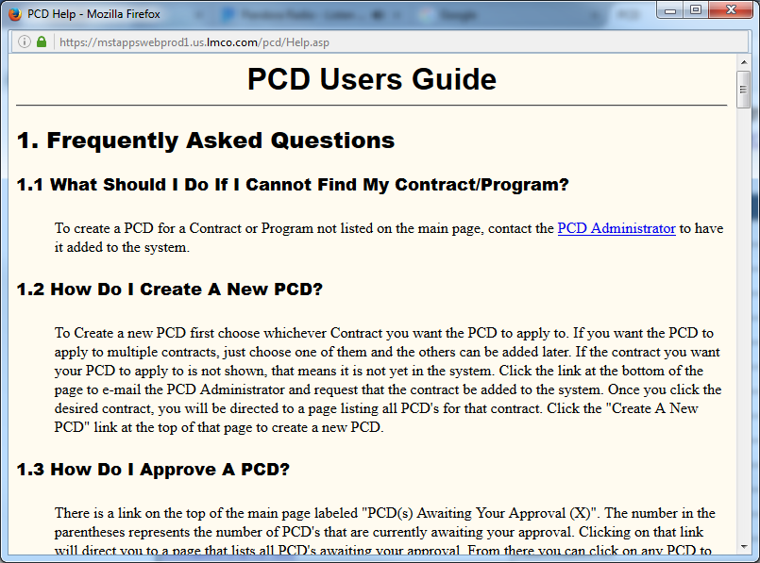

### Requirements

### Business Rules

### Views

### Functions

### Data Objects

### Enumerations

### Complexity

|  | Count |
| --- | --- |
| Inputs | 0 |
| Outputs | 0 |
| Inquires | 0 |
| Files/Tables | 0 |
| Ext. Files | 0 |
| Total: | 0 |

# Application Functions

The application is divided into the following functional parts: Contracts/Programs, Search, and Administration. Each piece is accessible from the home page. The home page initially displays a list of the contracts with a hyperlink to show all PCD's for each contract. The Programs tab may be chosen to change the view to a list of all programs with hyperlinks to show all PCD's for any program. Links are available for the Search and Administration options, although the Administration button is only available to users with Administration authority.

In addition to the main functions of the application, options are available to display help and to get statistics regarding all PCD's or just the PCD's associated with a specified contract or program.

## Contracts/Program List

Allows users to work with PCD's associated with the selected contract or program. This option is selected by clicking on the hyperlink for the desired contract or program on the home page. A list of PCD's associated with that contract or program is displayed. Initially only approved PCD's will be shown. PCD's of other states can be viewed by selecting the checkboxes for the desired states in the Show box at the top of the screen and clicking the Refresh List button. Selecting the hyperlink for any PCD allows the user to work with the individual PCD. PCD's that have an approved revision will appear with a gray background.

### Human Machine Interfaces

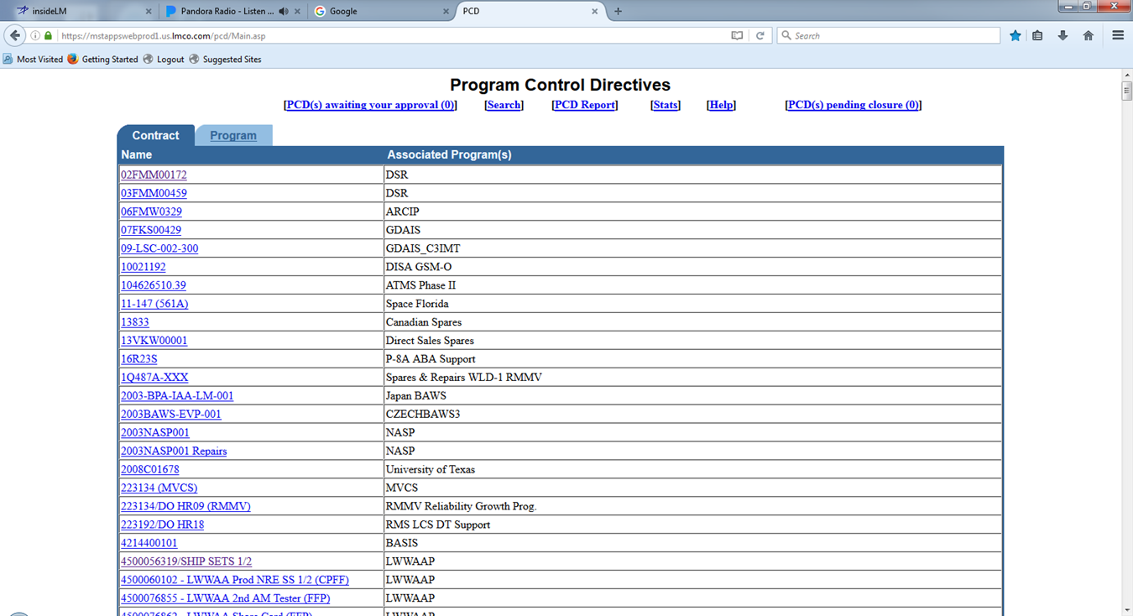

### Requirements

### Business Rules

### Views

### Functions

### Data Objects

### Enumerations

### Complexity

|  | Count |
| --- | --- |
| Inputs | 0 |
| Outputs | 0 |
| Inquires | 0 |
| Files/Tables | 0 |
| Ext. Files | 0 |
| Total: | 0 |

## Administration

The Administration option allows maintenance of the programs and contracts. It also allows addition/removal of system administration authorization. System administrators have access to the Administration option on the home page and are also allowed to edit any PCD in any state.

### Human Machine Interfaces

### Requirements

### Business Rules

### Views

### Functions

### Data Objects

### Enumerations

### Complexity

|  |  |
| --- | --- |
|  | Count |
| Inputs | 0 |
| Outputs | 0 |
| Inquires | 0 |
| Files/Tables | 0 |
| Ext. Files | 0 |
| Total: | 0 |

## PCD Summary

### Human Machine Interfaces

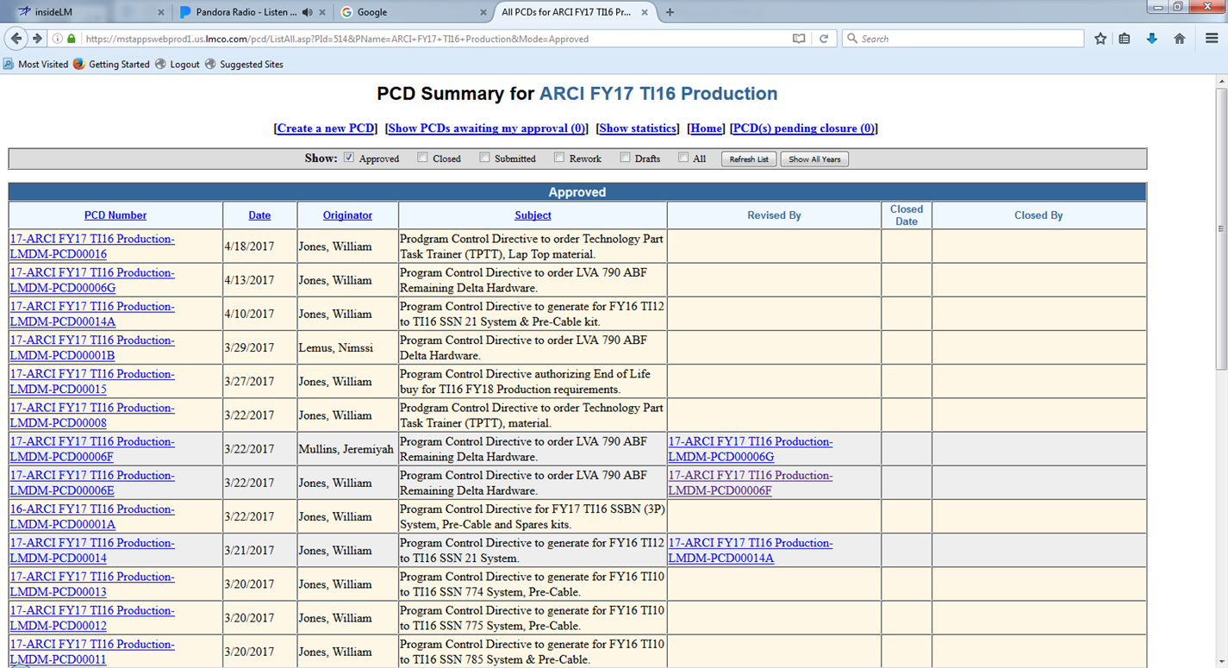

### Requirements

### Business Rules

### Views

### Functions

### Data Objects

### Enumerations

### Complexity

|  | Count |
| --- | --- |
| Inputs | 0 |
| Outputs | 0 |
| Inquires | 0 |
| Files/Tables | 0 |
| Ext. Files | 0 |
| Total: | 0 |

## PCD Report

### Human Machine Interfaces

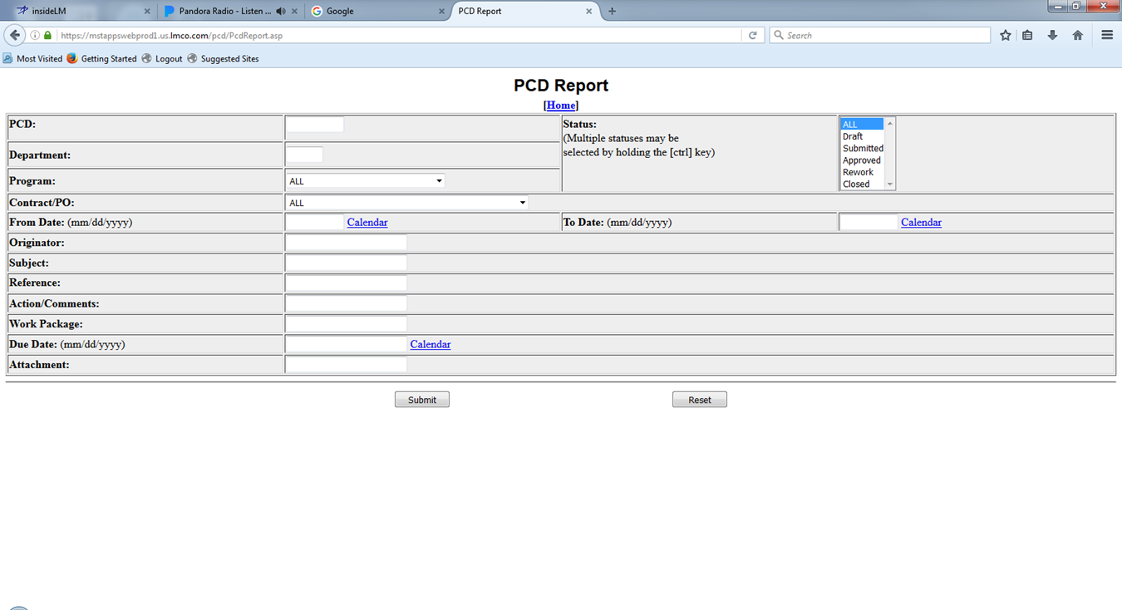

### Requirements

### Business Rules

### Views

### Functions

### Data Objects

### Enumerations

### Complexity

|  | Count |
| --- | --- |
| Inputs | 0 |
| Outputs | 0 |
| Inquires | 0 |
| Files/Tables | 0 |
| Ext. Files | 0 |
| Total: | 0 |

## PCD Statistics

### Human Machine Interfaces

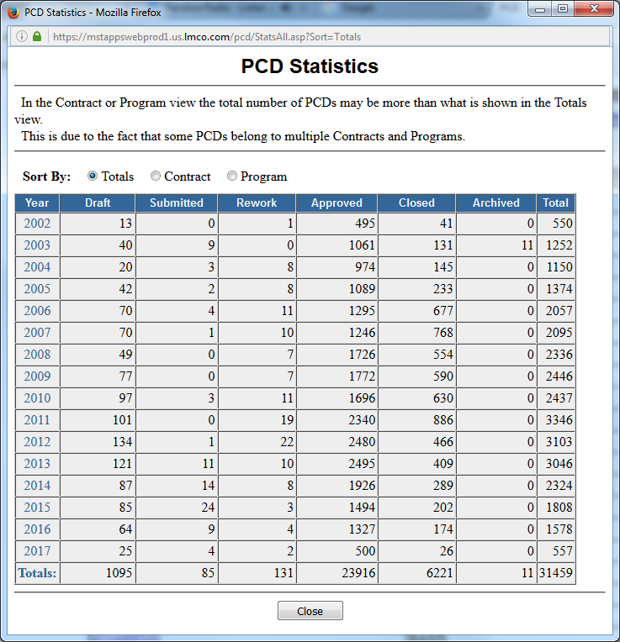

Figure 4‑1: PCD Statistics (Totals)

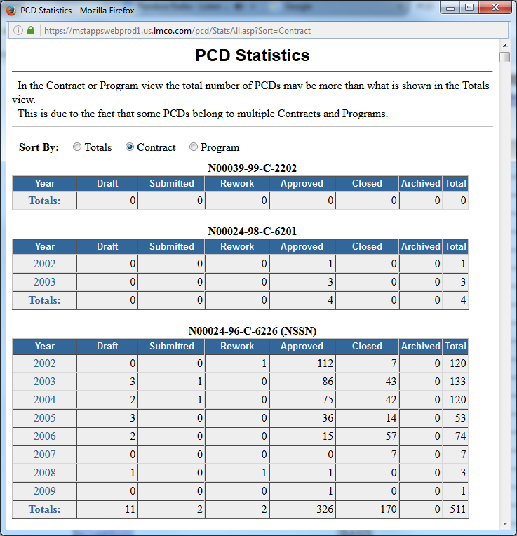

Figure 4‑2: PCD Statistics (Contract)

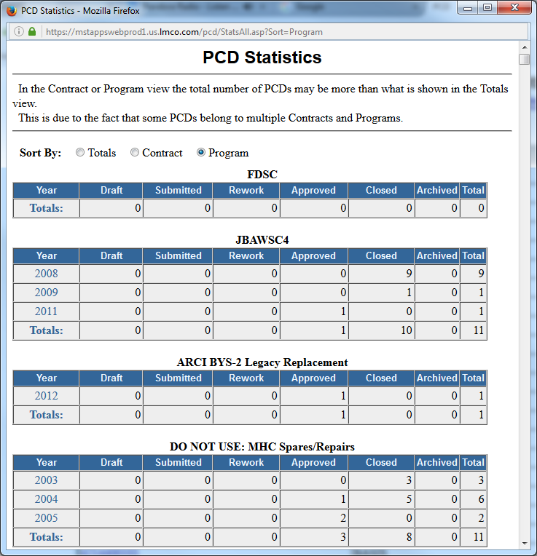

Figure 4‑3: PCD Statistics (Program)

### Requirements

### Business Rules

### Views

### Functions

### Data Objects

### Enumerations

### Complexity

|  | Count |
| --- | --- |
| Inputs | 0 |
| Outputs | 0 |
| Inquires | 0 |
| Files/Tables | 0 |
| Ext. Files | 0 |
| Total: | 0 |

## Contract Entry

### Human Machine Interfaces

### Requirements

### Business Rules

### Views

### Functions

### Data Objects

### Enumerations

### Complexity

|  | Count |
| --- | --- |
| Inputs | 0 |
| Outputs | 0 |
| Inquires | 0 |
| Files/Tables | 0 |
| Ext. Files | 0 |
| Total: | 0 |

## Program Entry

### Human Machine Interfaces

### Requirements

### Business Rules

### Views

### Functions

### Data Objects

### Enumerations

### Complexity

|  | Count |
| --- | --- |
| Inputs | 0 |
| Outputs | 0 |
| Inquires | 0 |
| Files/Tables | 0 |
| Ext. Files | 0 |
| Total: | 0 |

## User Entry

### Human Machine Interfaces

### Requirements

### Business Rules

### Views

### Functions

### Data Objects

### Enumerations

### Complexity

|  | Count |
| --- | --- |
| Inputs | 0 |
| Outputs | 0 |
| Inquires | 0 |
| Files/Tables | 0 |
| Ext. Files | 0 |
| Total: | 0 |

# Use Cases

This section introduces the relevant decomposed use cases with a use case diagram that depicts the use case names and relationships with stakeholders. Stakeholders can be either users or other system elements.

### [Use Case Name]

This section provides a brief description of the use case including any assumptions and pre/post conditions.

#### [Sequence | Activity] Diagram Name (optional)

This section will contain the sequence or activity diagram depicting the use case flows.

#### Basic Flow

This section will list the steps of the basic flow of events for the use case.

#### Alternate Flows

This section will list the steps for the alternate flow of events.

#### Exceptional Flows

This section will list the steps for the exceptional flow of events.

# Data Model

This section provides a data model for data structures used in the interfaces and data persisted in the data storage subsystem.

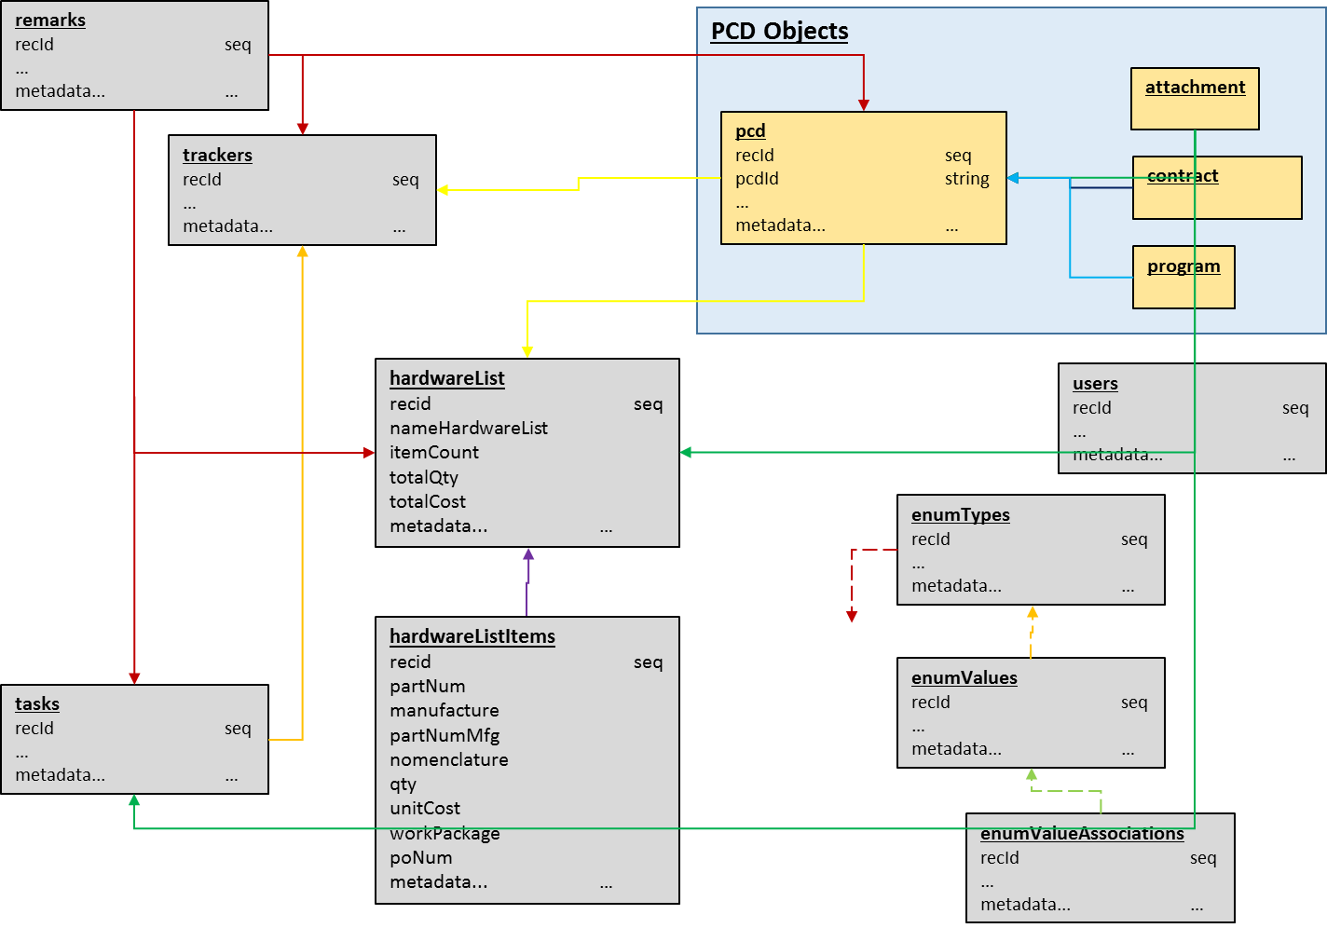

Figure 6‑1: Data Model

## Table Trackers

Contains all the data need to develop a PCD and track the development of the PCD.

Table 6‑2: Trackers

| Column Name | Data Type | Null | Description |
| --- | --- | --- | --- |
| Rec Id | Sequence | Not | The unique durable single field key assigned to the record. |
| Rec UUID | UUID | Not | Stores the Universally Unique Identifier (UUID) as defined by RFC 4122, ISO/IEC 9834-8:2005. |
| Fiscal Year | String | Not | The fiscal year the tracker is reporting on.. |
| Hull Number | String | Not | The hull number the tracker is reporting on. |
| Technical Insert | String | No | The technical insert the tracker is reporting on. |
| Funded Flag | Boolean |  | Flag indicating whether the program is funded. |
| FEA Flag | String |  | Flag indicating whether the work is being done under a Financial Exposure Authorization (FEA). |
| On Dock/Need Date | Date |  | The date the item(s) is to be delivered to the customer. |
| PCD Lead Time | Integer |  | The number of days before the ‘On Dock/Need Date’ the PCD should be completed. |
| Internal RDD Lead Time | Integer |  | The number of days before the ‘On Dock/Need Date’ the item should be completed by the production organization. |
| Internal RDD | Date |  | The date the item(s) should be complete by the production organization. |
| Delivery Lead Time | Integer |  | The number of days before the ‘On Dock/Need Date’ the item(s) should be delivered to the customer. |
| Delivery Required | Date |  | The date the item(s) is to be delivered to the customer. |
| Delivery Status | String |  | The delivery status of the items to the client. (‘’, Delivered, Lost, Shipped) |
| MAN PR | Boolean |  | Manassas purchase requisition flag |
| MAN DEL O/L | Date |  | Manassas delivery date outlook |
| CLW PR | Boolean |  | Clearwater purchase requisition flag |
| CLW DEL O/L | Date |  | Clearwater delivery date outlook |
| Part Number | String |  | Part Number or BOM. |
| Parts List Status | String |  | The status of the parts list preparation task. |
| Drawing Status | String |  | The status of the engineering drawings preparation task. |
| MOD | String |  |  |
| SLIN | String |  | Sub-line item number |
| Est Dollars | int |  | The estimated budget dollars of the PCD. |
| BOM Status | String |  | The status of the bill of materials preparation task. |
| Date Next Review | date |  | The date the task should next be reviewed. |
| BOILERPLATE |  |  | See ‘Table Boilerplate Suffix’. |

Referenced by:

2.2 - PCD Status View

2.3 - PCD Status Search / Report Parameters

2.4 - PCD Tracker Entry

## Table Program Control Directives (PCD)

Contains the high-level information regarding the PCD.

Table 6‑3: Program Control Directives (PCD)

| Column Name | Data Type | Null | Description |
| --- | --- | --- | --- |
| Rec Id | Sequence | Not | The unique durable single field key assigned to the record. |
| Rec UUID | UUID | Not | Stores the Universally Unique Identifier (UUID) as defined by RFC 4122, ISO/IEC 9834-8:2005. |
| Tracker ID | FK |  |  |
| Tracker UUID | FK |  |  |
| PCD | String | Not | A unique identifier for each PCD. It is automatically generated. For approved PCD's the format is "Last two digits of the year approved-program-company-PCDxxxxx" eg. 01-ARCI-LMDM-PCD00010. For unapproved PCD's the number is in the format "Draft-six digit number" e.g. Draft-000010 |
| Subject | String | Not | The subject of this PCD; Typed by the author |
| Classification Code | String | Not |  |
| Department | String | Not | Text box prefilled with department of the originator, but can be changed to any department |
| Revision | String |  | This is an uneditable field that shows whether this PCD has had a revision approved. If so, it will show the number of that PCD. If not, it will simply say "Current". |
| Programs |  |  | Author may select which program(s) this PCD applies to from a list of all programs that the chosen contract(s) apply to |
| Originator | String |  | Uneditable field that shows the name of the PCD's originator |
| Approver |  |  | Selected by author from a list of approvers for each contract that a PCD is associated with. One or more approvers must be selected from each Contract that the PCD pertains to. If the same person is an approver for multiple contracts, they may approve for both. |
| Current Status | String |  | Uneditable field filled with the current state of the PCD. In the case of rework, approved, or closed the name of the approver(s) who put it in that state and the date they did it will also be displayed |
| Action Responsible Persons |  |  | People that are responsible for the action of the PCD. Lookup select by author or a team name that the author enters |
| PCD Required Date | Date |  |  |
| Contracts |  |  | Shows all contracts or purchase orders that this PCD applies to. |
| Reference |  |  | Anything this PCD may be in reference to as entered by the author in a text area. |
| Action |  |  | The main content of the PCD |
| Program Recipients |  |  | Uneditable list of all program recipients. These are the all people on the program recipient lists of all programs associated with this PCD. They will receive a notification e-mail when the PCD is approved. |
| Additional Recipients |  |  | Any additional people that will get notified when the PCD is approved. The author chooses them through Lookup |
| Work Package |  |  |  |
| Attachments |  |  | Any files can be stored with the PCD by the author |
| Rework Remarks |  |  | An approver can fill this field out when designating a PCD for rework. It should contain information regarding what changes are necessary |
| Program to Use in PCD Number | String |  | The author must select the program to have the system use when it assigns a PCD number to the PCD. To set it the author must select a program from the programs box and click the set code button. |
| BOILERPLATE |  |  | See ‘Table Boilerplate Suffix’. |

Referenced by:

2.2 - PCD Status View

2.3 - PCD Status Search / Report Parameters

## Table Hardware Lists

Is the parent record for the hardware list and contains the high-level information about the hardware list.

Table 6‑4: Hardware Lists

| Column Name | Data Type | Null | Description |
| --- | --- | --- | --- |
| Rec Id | Sequence | Not | Individual unique identification id for the associated enumeration value. |
| Rec UUID | UUID | Not | Stores the Universally Unique Identifier (UUID) as defined by RFC 4122, ISO/IEC 9834-8:2005. |
| nameHardwareList |  |  |  |
|  |  |  |  |
|  |  |  |  |
|  |  |  |  |
|  |  |  |  |
|  |  |  |  |
|  |  |  |  |
| BOILERPLATE |  |  | See ‘Table Boilerplate Suffix’. |

Referenced by:

Add reference here

## Table Hardware List Items

Contains the line item information for the hardware list and the child of the hardware list.

Table 6‑5: Hardware List Items

| Column Name | Data Type | Null | Description |
| --- | --- | --- | --- |
| Rec Id | Sequence | Not | Individual unique identification id for the associated enumeration value. |
| Rec UUID | UUID | Not | Stores the Universally Unique Identifier (UUID) as defined by RFC 4122, ISO/IEC 9834-8:2005. |
| partNumber |  |  |  |
| vendor |  |  |  |
| cotsBayQty |  |  |  |
| fatEqtQty |  |  |  |
| incoQty |  |  |  |
| lvaDeltaQty |  |  |  |
| totalQty |  |  |  |
| unitCost |  |  |  |
| externalCost |  |  |  |
|  |  |  |  |
| BOILERPLATE |  |  | See ‘Table Boilerplate Suffix’. |

Referenced by:

Add reference here

## Table Remarks

Contains a remark information about a given PCD, tasks, or item. There can be multiple remarks linked to the parent record.

Table 6‑6: Remarks

| Column Name | Data Type | Null | Description |
| --- | --- | --- | --- |
| Rec Id | Sequence | Not | Individual unique identification id for the associated enumeration value. |
| Rec UUID | UUID | Not | Stores the Universally Unique Identifier (UUID) as defined by RFC 4122, ISO/IEC 9834-8:2005. |
| Parent Rec ID | Integer | Not |  |
| Parent Rec UUID | UUID | Not |  |
| Remark Type | Enumeration |  | tracker, task, review |
| Date | date |  |  |
| User | text |  |  |
| Remark | text |  |  |
|  |  |  |  |
|  |  |  |  |
| BOILERPLATE |  |  | See ‘Table Boilerplate Suffix’. |

Referenced by:

Add reference here

## Table Tasks

Contains the task information for a specific tracker record. There can be multiple task records linked to the parent tracker record.

Table 6‑7: Tasks

| Column Name | Data Type | Null | Description |
| --- | --- | --- | --- |
| Rec Id | Sequence | Not | Individual unique identification id for the associated enumeration value. |
| Rec UUID | UUID | Not | Stores the Universally Unique Identifier (UUID) as defined by RFC 4122, ISO/IEC 9834-8:2005. |
| Parent Rec ID | Integer | Not |  |
| Parent Rec UUID | UUID | Not |  |
| Task Type | Enumeration |  |  |
| Description |  |  |  |
|  |  |  |  |
| BOILERPLATE |  |  | See ‘Table Boilerplate Suffix’. |

Referenced by:

Add reference here

## Table User Tasks

Is this table really needed?

Table 6‑8: User Tasks

| Column Name | Data Type | Null | Description |
| --- | --- | --- | --- |
| Rec Id | Sequence | Not | Individual unique identification id for the associated enumeration value. |
| Rec UUID | UUID | Not | Stores the Universally Unique Identifier (UUID) as defined by RFC 4122, ISO/IEC 9834-8:2005. |
| Task Type | Enumeration |  |  |
| User Role | Enumeration |  |  |
| User |  |  |  |
| Task Status | Enumeration |  |  |
|  |  |  |  |
|  |  |  |  |
|  |  |  |  |
|  |  |  |  |
| BOILERPLATE |  |  | See ‘Table Boilerplate Suffix’. |

Referenced by:

Add reference here

## Table Contracts

Contains the contracts available for use in the PCD. Enumeration?

Table 6‑9: Contracts

| Column Name | Data Type | Null | Description |
| --- | --- | --- | --- |
| Rec Id | Sequence | Not | Unique integer for the enumeration type to set it apart from the other enumeration types. |
| Rec UUID | UUID | Not | Unique identifier for the enumeration type to set it apart from the other enumeration types. |
| Contract ID | Text | Not |  |
| Contract Description | Text |  |  |
|  |  |  |  |
|  |  |  |  |
|  |  |  |  |
|  |  |  |  |
| BOILERPLATE |  |  | See ‘Table Boilerplate Suffix’. |

Referenced by:

2.3 - PCD Status Search / Report Parameters

## Table Search Parameters

Contains the ‘where’ clause from the users last successful search and/or report.

Table 6‑10: Search Parameters

| Column Name | Data Type | Null | Description |
| --- | --- | --- | --- |
| Rec Id | Sequence | Not | Unique integer for the enumeration type to set it apart from the other enumeration types. |
| Rec UUID | UUID | Not | Unique identifier for the enumeration type to set it apart from the other enumeration types. |
| User ID | Text | Not |  |
| Where Clause | Text | Not |  |
|  |  |  |  |
|  |  |  |  |
|  |  |  |  |
|  |  |  |  |
| BOILERPLATE |  |  | See ‘Table Boilerplate Suffix’. |

Referenced by:

Add reference here

## Table Attachments

The record containing the attachment information. There can be multiple attachment records linked to the parent record.

Table 6‑11: Attachments

| Column Name | Data Type | Null | Description |
| --- | --- | --- | --- |
| Rec Id | Sequence | Not | Unique integer for the enumeration type to set it apart from the other enumeration types. |
| Rec UUID | UUID | Not | Unique identifier for the enumeration type to set it apart from the other enumeration types. |
| File Type | Enumeration | Not |  |
| Filename |  | Not |  |
| File Extension | Enumeration | Not |  |
| Directory Path |  |  |  |
|  |  |  |  |
|  |  |  |  |
|  |  |  |  |
|  |  |  |  |
| BOILERPLATE |  |  | See ‘Table Boilerplate Suffix’. |

Referenced by:

Add reference here

## Table Enumeration Types

The overarching data object that represents whole enumerations in the database by their names.

Table 6‑11: Enumeration Types

| Column Name | Data Type | Null | Description |
| --- | --- | --- | --- |
| Rec Id | Sequence | Not | Unique integer for the enumeration type to set it apart from the other enumeration types. |
| Rec UUID | UUID | Not | Unique identifier for the enumeration type to set it apart from the other enumeration types. |
| Enumeration Type | text |  | Identifying name of the enumeration in the database. |
| Description | text |  | Brief description of the enumeration. |
| Date Created | timestamp with timezone |  | Date the enumeration was created in the database. |
| Date Modified | timestamp with timezone |  | Date the enumeration was last updated. |
| Last Modified By | text |  | Which system administrator last updated the enumeration? |
| Classification | text |  | Overall classification of the enumeration and all of its values. |
| Constant | bool |  | Whether or not the enumeration is constant (unchangeable, probably used in the system), or dynamic (changeable, probably just used for visualization purposes). |
|  |  |  |  |
| BOILERPLATE |  |  | See ‘Table Boilerplate Suffix’. |

Referenced by:

Add reference here

## Table Enumeration Values

Individual enumeration values that belong under a particular enumeration type.

Table 6‑12: Enumeration Values

| Column Name | Data Type | Null | Description |
| --- | --- | --- | --- |
| Rec Id | Sequence | Not | Unique integer for the enumeration value to set it apart from the other enumeration values. |
| Rec UUID | UUID | Not | Unique identifier for the enumeration value to set it apart from the other enumeration values. |
| Enumeration Type | uuid | not | Name/identifier of the overarching enumeration type that this value belongs to. |
| Enumeration Value | text | not | The actual specific enumeration value. |
| Ordering | int |  | Integer value used to create a custom sort order not possible programmatically. |
| Enumeration Display Name | text |  |  |
| Description | text |  | Brief description of the enumeration value. |
| Constant | bool |  | Whether or not enumeration value is unchangeable or dynamic. |
|  |  |  |  |
| BOILERPLATE |  |  | See ‘Table Boilerplate Suffix’. |

Referenced by:

Add reference here

## Table Enumeration Value Associations

Values that are in some way associated with a particular enumeration value. For example, an associated value would be a displayable name for a particular enumeration value to use whenever it is rendered in a selectable drop-down list in a GUI.

Table 6‑13: Enumeration Value Associations

|  |  |  |  |
| --- | --- | --- | --- |
| Column Name | Data Type | Null | Description |
| Rec Id | Sequence | Not | Unique integer for the enumeration value to set it apart from the other enumeration values. |
| Rec UUID | UUID | Not | Unique identifier for the enumeration value to set it apart from the other enumeration values. |
| Enumeration Value UUID | uuid |  | UUID for enumeration value this associated value is connected to. |
| Associated Enumeration Value | text |  | Actual associated enumeration value for particular enumeration value. |
| Data Type | text |  | Datatype that associated value should be rendered as. |
| Value Descriptor | text |  | Unique descriptor of associated value used to identify particular associated value. |
| Constant | bool |  | Whether or not associated value is associated with an enumeration value that is dynamic or not. |
|  |  |  |  |
| BOILERPLATE |  |  | See ‘Table Boilerplate Suffix’. |

Referenced by:

Add reference here

## Table Boilerplate Suffix

This a set of fields that would part of every table. Because the filed definitions don’t change between tables they are defined once here and referred to as “**BOILERPLATE**” at the end each table.

Table 6‑14: Boilerplate

| Column Name | Data Type | Null | Description |
| --- | --- | --- | --- |
| status | Char(1) | Not | A 1 character code for the status of the record, (Current, Error, Historical, New, Processing, Waiting).  DEFAULT 'C' |
| status_by | Varchar(50) | Not | The user who last changed the status of the record.  DEFAULT USER |
| status_date | Timestamp | Not | The date when the record status was last changed.  DEFAULT CLOCK_TIMESTAMP() |
| insert_date | Timestamp |  | The date the record was created.  DEFAULT CLOCK_TIMESTAMP() |
| insert_by | Varchar(50) |  | The user/function that created the record.  DEFAULT USER |
| update_date | Timestamp |  | The date the record was last modified. |
| update_by | Varchar(50) |  | The user/function that last updated the record. |
| delete_flag | Boolean |  | A logical flag used to ignore the record as if it was deleted.  DEFAULT 'FALSE |
| delete_date | Timestamp |  | The date the logical delete flag was set. |
| delete_by | Varchar(50) |  | The user/function that set the logical delete flag. |
| hidden_flag | Boolean |  | A flag used to hide/exclude the record from pick lists.  DEFAULT 'FALSE |
| hidden_date | Timestamp |  | The date the hidden flag was set. |
| hidden_by | String |  | The user/function that set the hidden flag. |
|  |  |  |  |

Referenced by:

Add reference here

## Table blank

The overarching data object that represents whole enumerations in the database by their names.

Table 6‑1: Blank

| Column Name | Data Type | Null | Description |
| --- | --- | --- | --- |
| Rec Id | Sequence | Not | Unique integer for the enumeration type to set it apart from the other enumeration types. |
| Rec UUID | UUID | Not | Unique identifier for the enumeration type to set it apart from the other enumeration types. |
|  |  |  |  |
|  |  |  |  |
|  |  |  |  |
|  |  |  |  |
|  |  |  |  |
|  |  |  |  |
| BOILERPLATE |  |  | See ‘Table Boilerplate Suffix’. |

Referenced by:

Add reference here

# [CSCI Name] CSCI

This begins the definition of “WILLS” for the function. This section should include a CSCI block diagram which includes the CSCs that are to be described below. Requirements may be written in this paragraph if they apply to all CSCs.

## [CSC Name] CSC

This section should start with a brief description of the CSC.

### [Function Name]

This section describes a function of the CSC. Each function allocated to the CSC should reside under its own heading, so there may be multiple sections. Test methods can be embedded within the descriptions. If so, place a note in section 2.4 that states the embedded approach.

#### Test Method

This section provides CQT level test description for the function described above.

#### Algorithms (if applicable)

This section should describe any algorithms needed for the SW team to implement.

#### SW Reuse (if applicable)

This section examines the proposed software reuse that was identified during the replan estimation process. (see Alan’s ppt at: <https://www.silcweb.com/silc/?u=bpw>).

#### Requirements Traceability

This section provides a traceability matrix for the SSS and PBS requirements related to the CSC specification.

## Data Model

This section provides a data model for data structures used in the interfaces and data persisted in the data storage subsystem.

## Interfaces

This section provides interface definitions for GUIs or public interfaces that cross subsystem boundaries.

### Graphical Interfaces (if applicable)

This section provides applicable GUI mockups with description.

### Message Interfaces (if applicable)

This section provides message interface definitions, including message names, parameter list, and return values, if applicable.

#### Provided Interfaces

This section describes the public interfaces provided by the CSCI.

#### Required Interfaces

This section describes the public interfaces required by the CSCI.

# Appendixes

## Acronyms

| Acronym | Description |
| --- | --- |
| ARCI | Acoustic Rapid Commercial-Off-The-Shelf Insertion |
| BOM | Bill of Materials |
| CAM | Control Account Manager |
| CLR | Clearwater |
| ER | Engineering Release |
| EVM | Earned Value Management |
| FEA | Financial Exposure Authorization |
| LMDM | Lockheed Martin Data Management |
| MAN | Manassas |
| MPM |  |
| PC |  |
| PCD | Program Control Directive |
| PM | Project Manager |
| PN | Part Number |
| PO | Purchase Order |
| POP | Period of Performance |
| PPM |  |
| PR | Purchase Requisition |
| RDD | Required Delivery Date |
| SLIN | Sub-Line Item Number |
| TI | Technology Insertion |
| iWAD | “Initial” Work Authorization Directive |

## Enumeration Types

| Enumeration | Value | Code | Description |
| --- | --- | --- | --- |
| Action |  |  |  |
| Approvers |  |  |  |
| Classifications |  |  |  |
| Contracts |  |  |  |
| Departments |  |  |  |
| Fiscal Year |  |  |  |
| Hull |  |  |  |
| Lead Time Delivery |  |  |  |
| Lead Time PCD |  |  |  |
| Programs |  |  |  |
| Role |  |  |  |
| Status Delivery |  |  |  |
| Status Drawings |  |  |  |
| Status Parts List |  |  |  |
| Tasks |  |  |  |
| Technology Insertion |  |  |  |
| Users |  |  |  |

## Enumeration Values

| Enumeration | Value | Code | Description |
| --- | --- | --- | --- |
|  |  |  |  |
| Authorized Users |  |  |  |
| Contract |  |  |  |
|  |  |  |  |
| FEA |  | NA |  |
|  |  | N |  |
|  |  | Y |  |
|  |  |  |  |
| Fiscal Year |  |  |  |
| Hull |  |  |  |
|  |  |  |  |
|  |  |  |  |
| Lead Time Delivery |  |  |  |
| Lead Time PCD |  |  |  |
|  |  |  |  |
| State PCD |  | D | Draft |
|  |  | S | Submitted |
|  |  | R | Rework |
|  |  | A | Approved |
|  |  |  |  |
|  |  |  |  |
| Status Bill of Materials |  | “” | Blank |
|  |  | PR | Pre-Release |
|  |  | R | Release |
|  |  |  |  |
| Status Delivery |  | “” | Blank |
|  |  | D | Delivered |
|  |  | L | Lost |
|  |  | S | Shipped |
|  |  |  |  |
| Status Drawings |  | “” | Blank |
|  |  | PR | Pre-Release |
|  |  | R | Release |
| Status Parts List |  | “” | Blank |
|  |  | PR | Pre-Release |
|  |  | R | Release |
|  |  |  |  |
| Status PCD |  | A | Approved |
|  |  | R | Rework |
|  |  | P | Pending |
|  |  | X | No Action Required |
|  |  |  |  |
|  |  |  |  |
| Task Type |  | “” | Blank |
|  |  | BOM | Bill of Materials |
|  |  | DWG | Drawings |
|  |  | PCD | Program Control Directives |
|  |  | PN | Part Number |
|  |  | PR | Purchase Requisition |
|  |  |  |  |
| Technology Insertion |  |  |  |
|  |  |  |  |
|  |  |  |  |
|  |  |  |  |